**;**[Amazon CloudWatch Tutorial | AWS Certification | Cloud Monitoring Tools |](https://www.youtube.com/watch?v=__knpcBRLHg" \o "Amazon CloudWatch Tutorial | AWS Certification | Cloud Monitoring Tools | AWS Tutorial | Edureka)

**URL for this tutorial**

**https://www.youtube.com/watch?v=\_\_knpcBRLHg**

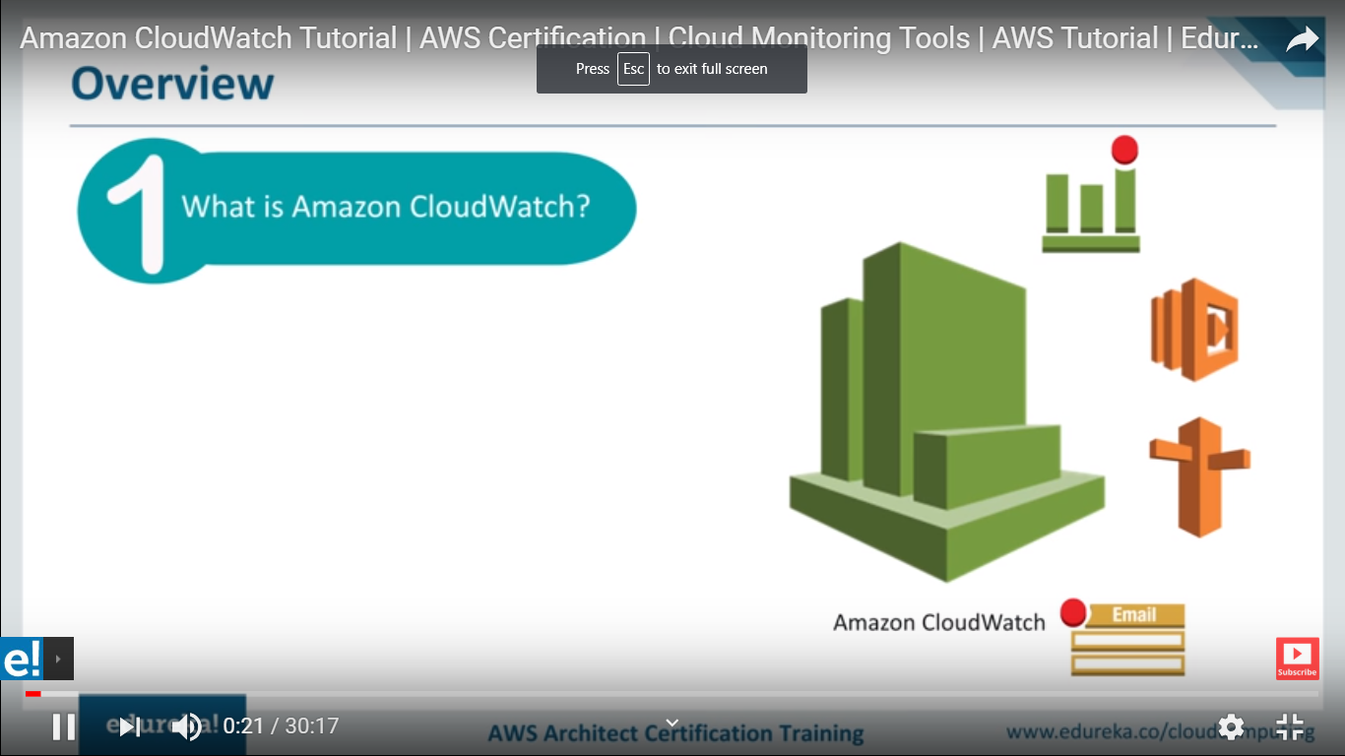

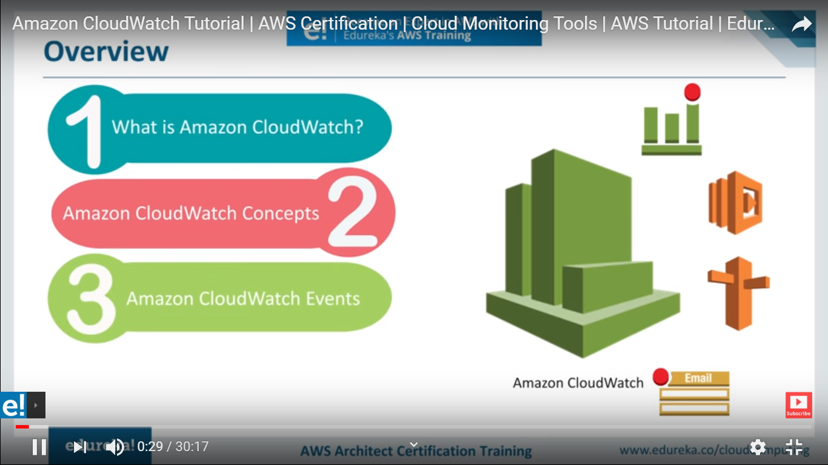

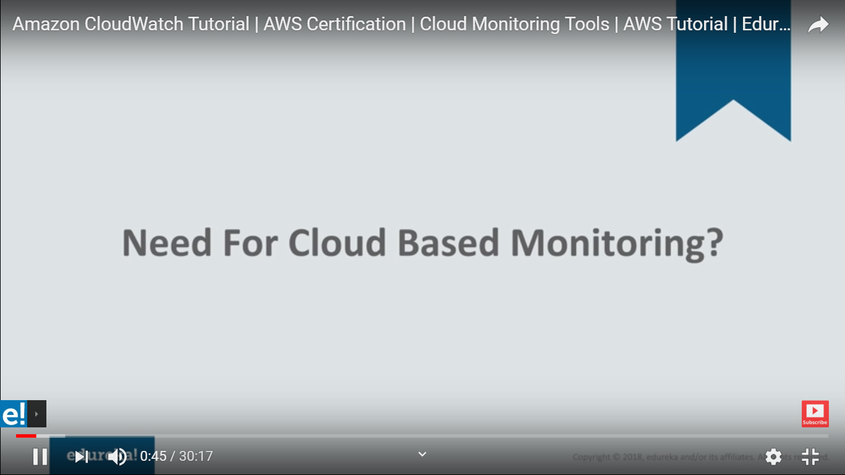

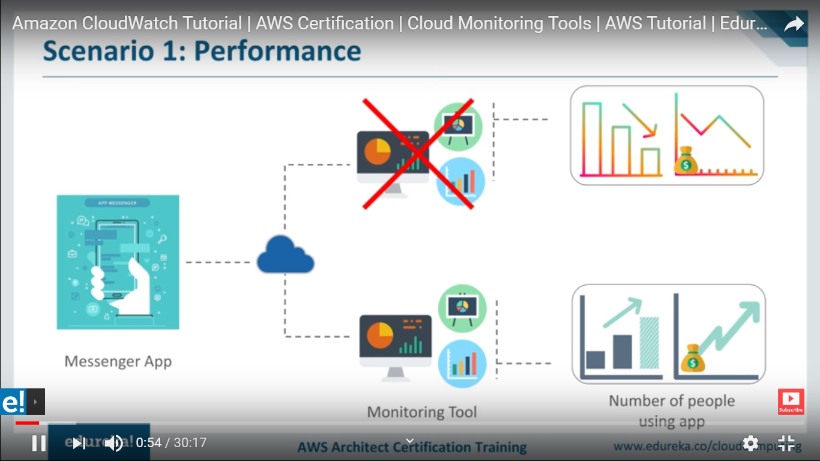

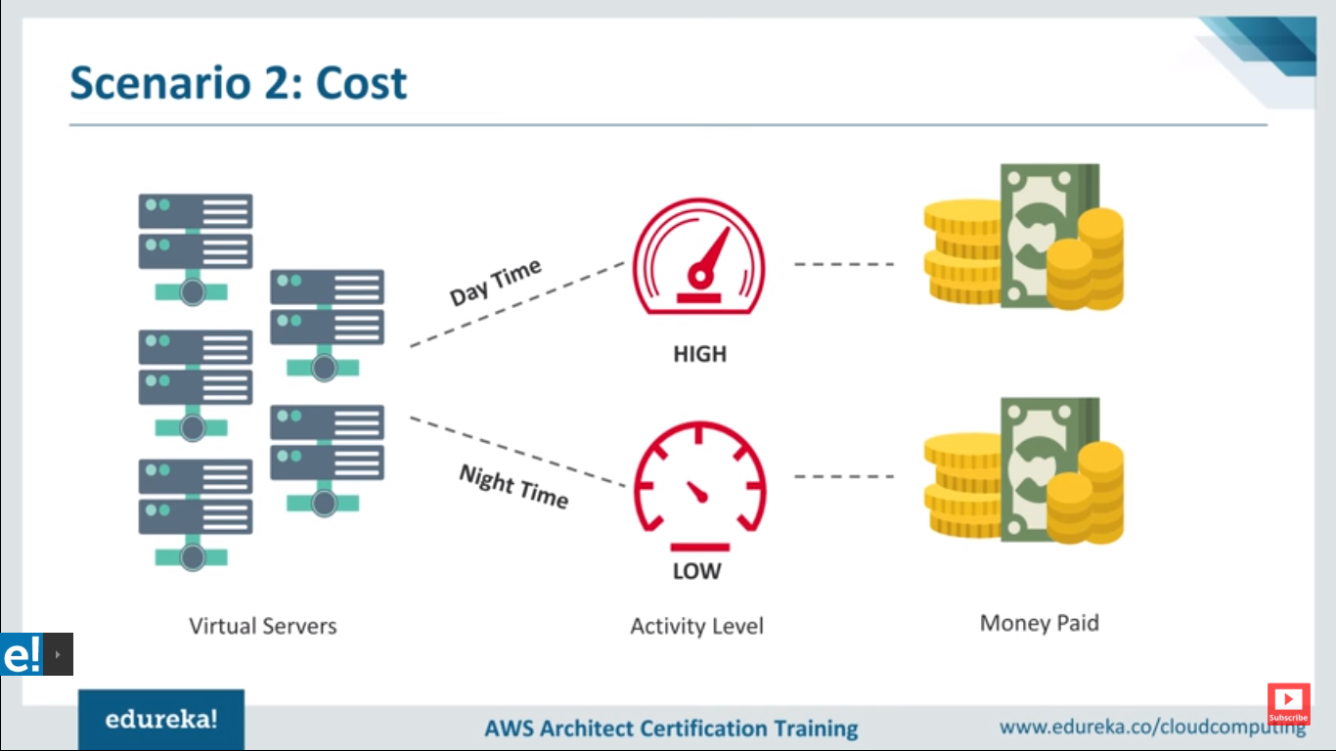

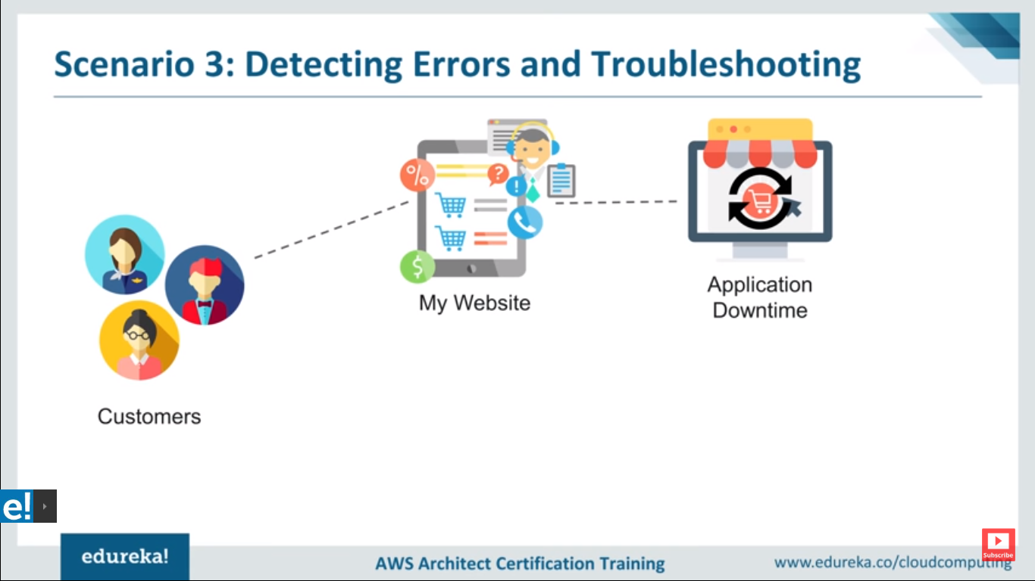

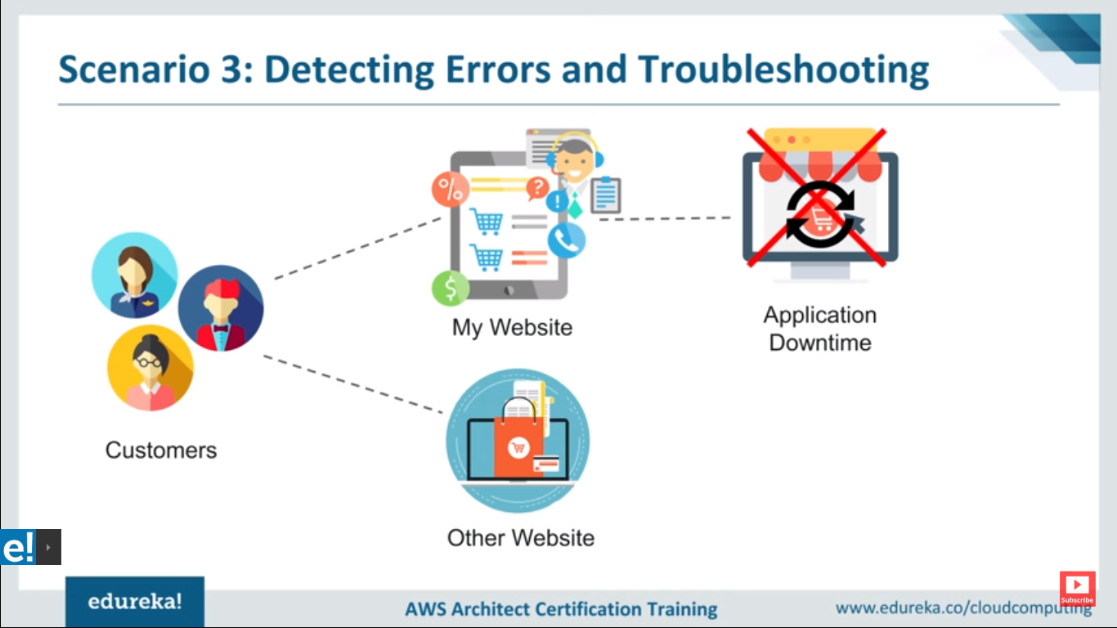

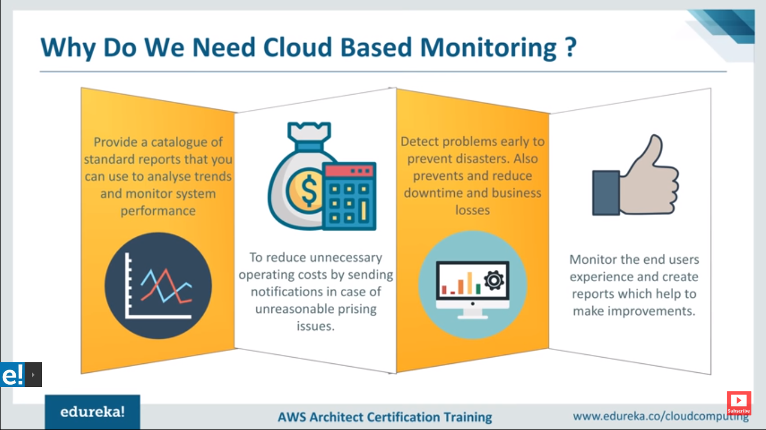

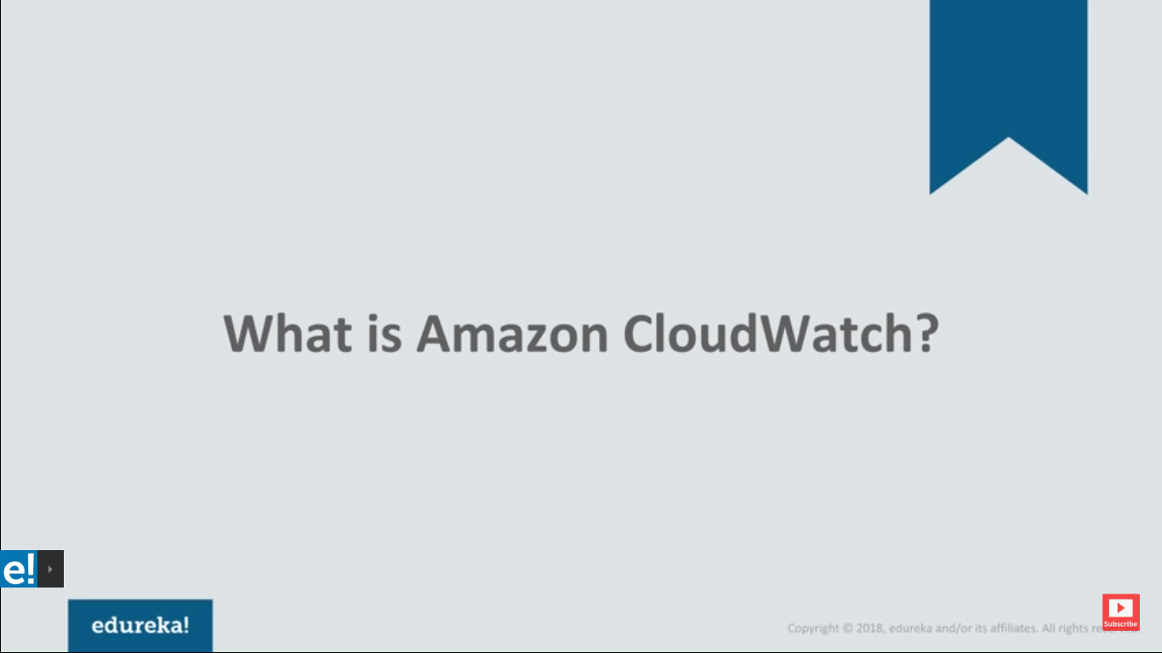

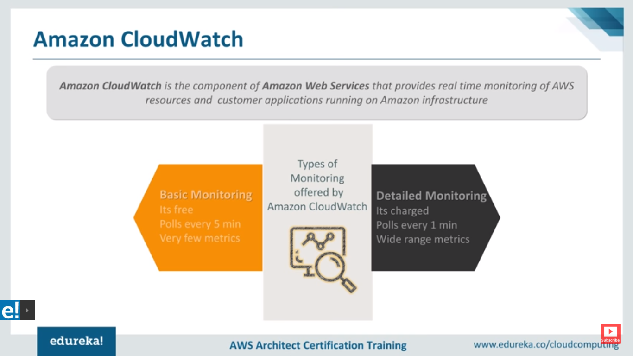

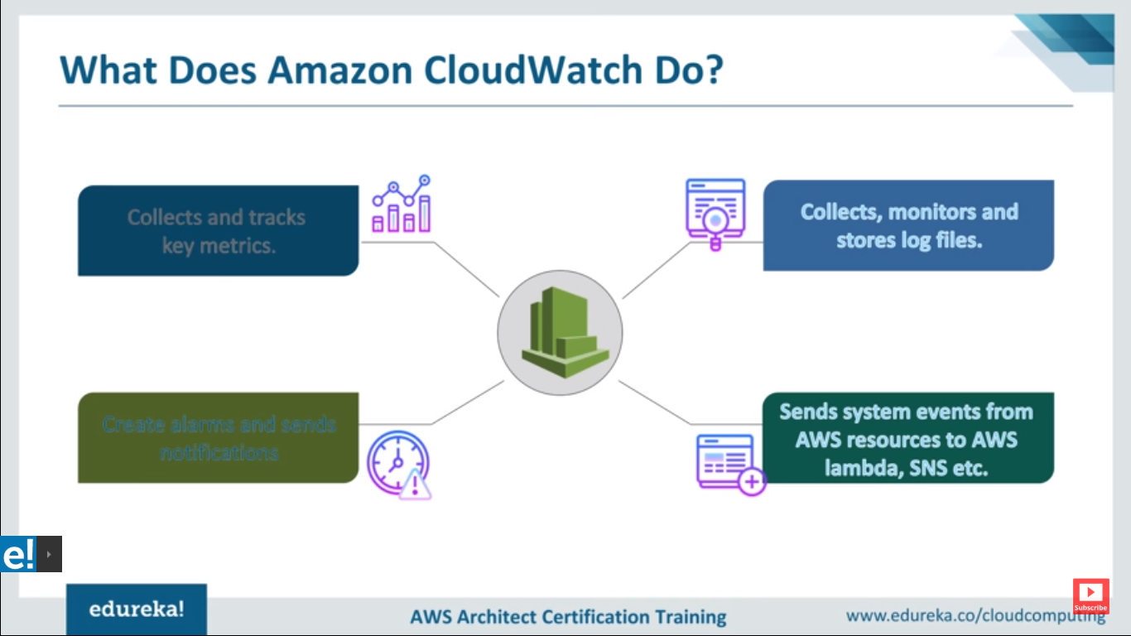

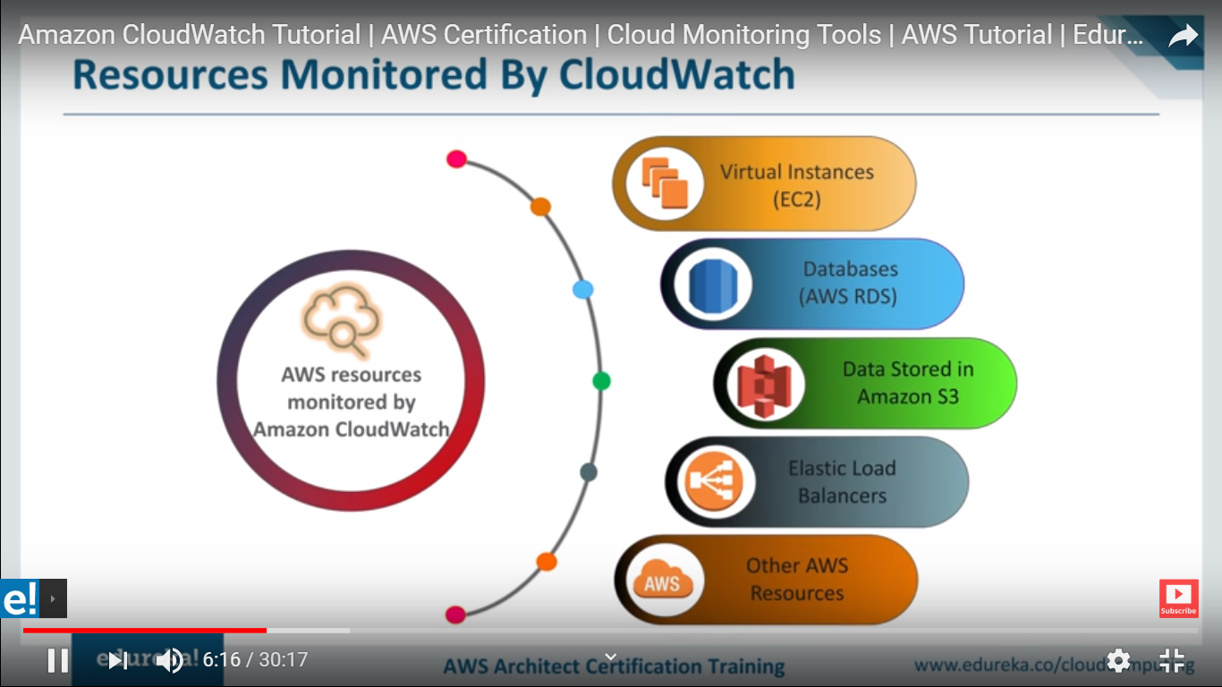

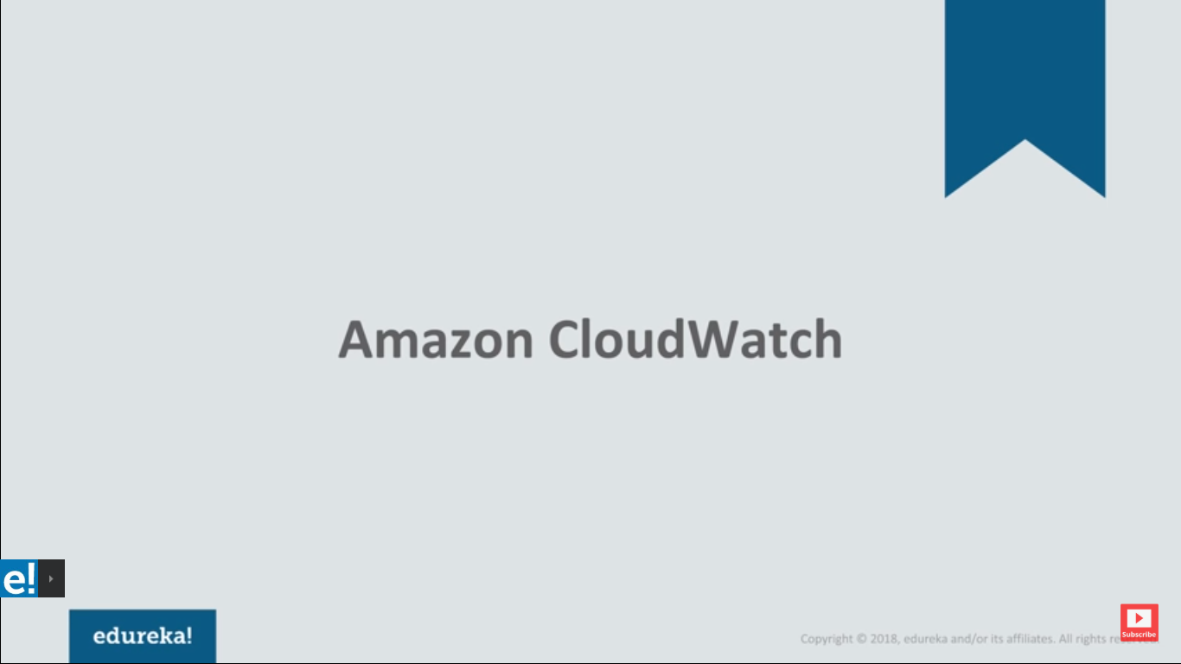

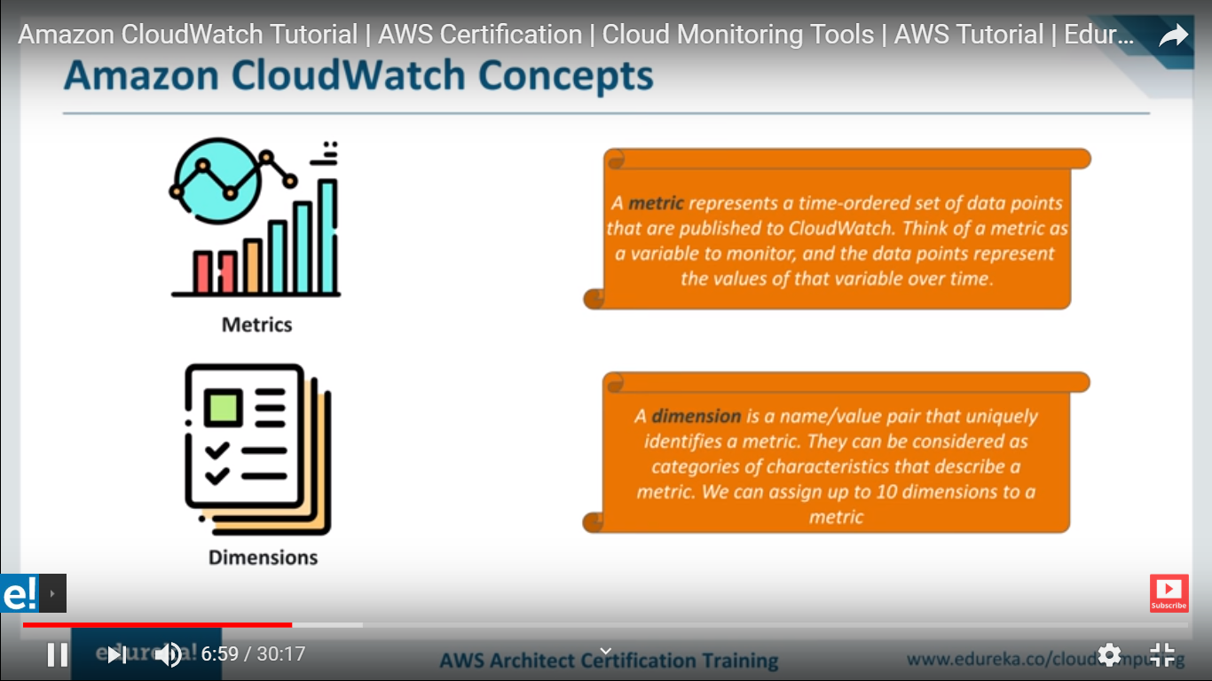

**Dimension is Name+value which describe metric**

**What is Metrics :**

**Very imp site for Detail monitoring for Metrics.**

[**https://www.stratoscale.com/blog/cloud/get-started-amazon-cloudwatch-monitor-ec2-instances/**](https://www.stratoscale.com/blog/cloud/get-started-amazon-cloudwatch-monitor-ec2-instances/)

**(This document mentioned how to set alarm for cpu,network etc)**

**-----------------------------------------------------------------------------------------------------**

**Metrics** are data about the performance of your systems. ... Amazon CloudWatch can load all the **metrics** in your account (both **AWS** resource **metrics** and application **metrics** that you provide) for search, graphing, and alarms.

---------------------------------------------------------------------------------------------------------------------------

**Metrics** are grouped first by namespace, and then by the various dimension combinations within each namespace. For example, you can view all EC2**metrics**, EC2 **metrics** grouped by instance, or EC2**metrics** grouped by Auto Scaling group. Only the**AWS** services that you're using send **metrics** to Amazon **CloudWatch**.

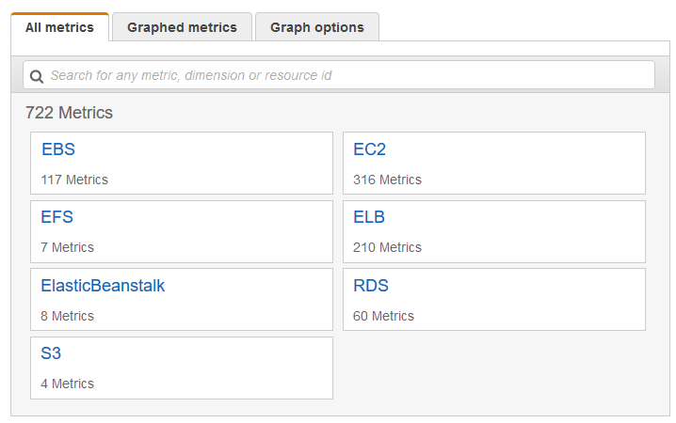

For **example**, the **CPU usage of a particular EC2 instance is one metric**provided by **Amazon EC2**. The data points themselves can come from any application or business activity from which you collect data. **AWS** services send **metrics** to CloudWatch, and you can send your own custom **metrics** to CloudWatch.

# **Using Amazon CloudWatch** Metrics(<https://docs.aws.amazon.com/AmazonCloudWatch/latest/monitoring/working_with_metrics.html>)

**Metrics are data about the performance of your systems.** By default, several services provide free metrics for resources (such as Amazon EC2 instances, Amazon EBS volumes, and Amazon RDS DB instances). You can also enable detailed monitoring some resources, such as your Amazon EC2 instances, or publish your own application metrics. Amazon CloudWatch can load all the metrics in your account (both AWS resource metrics and application metrics that you provide) for search, graphing, and alarms.

Metric data is kept for 15 months, enabling you to view both up-to-the-minute data and historical data.

Creating CPU Alarm : <https://docs.aws.amazon.com/AmazonCloudWatch/latest/monitoring/US_AlarmAtThresholdEC2.html>

Note : You can create your own custom metrics I think API Gateway metrics is custom metrics

**Dimensions**

Let’s say you’ve got a FreeMemory metric in your MySite namespace. What if you want to add this to another instance? You need yet another degree of freedom, Dimensions. In this example the InstandId is the dimension being used, but you can set others if you like.

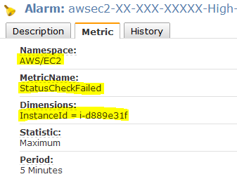

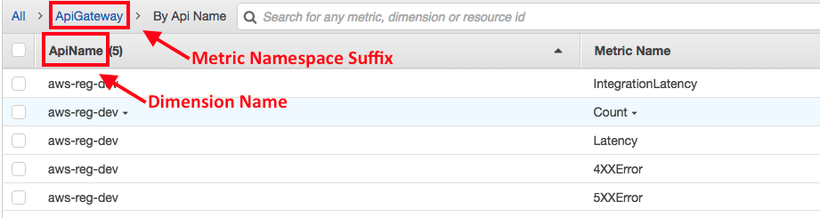

Example:

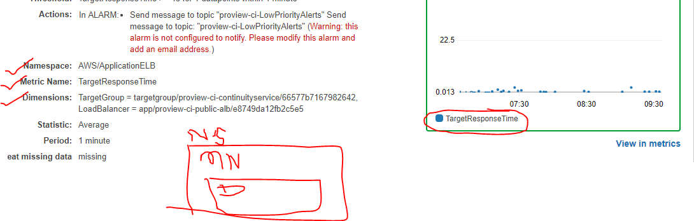

Namespace :

Metric Name : Datapoint which need to monitored

Dimensions :

Metrics data-🡪 datapoint(TragetResponse time,HTTPCode\_ELB\_503\_Count,ProcessedBytes,HTTPCode\_Target\_3XX\_Count,ConsumedLCUs,RequestCount) or **monitoring and analysis particular resources all the factors(matrics)**

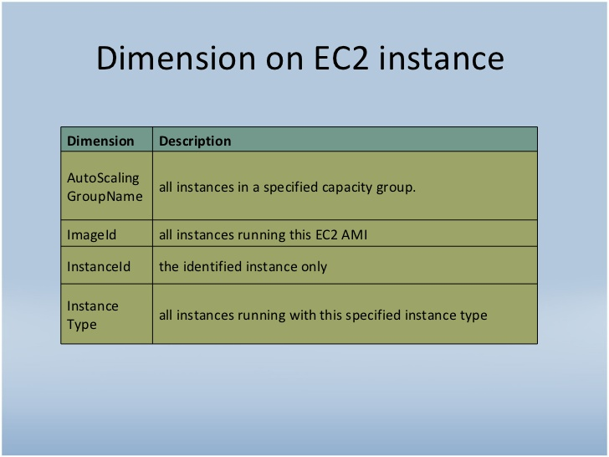

**Metrics === factor of action on resources**

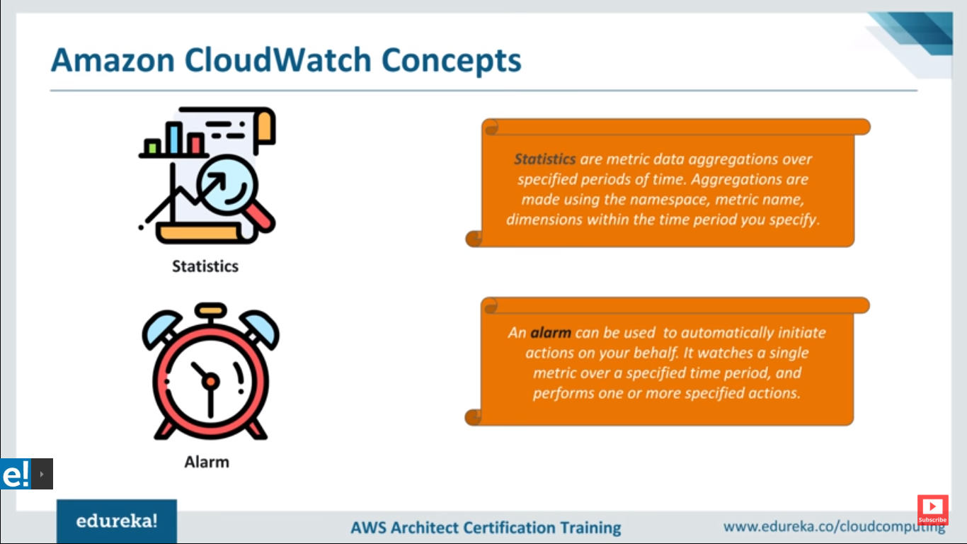

**step to create alarms**

[**https://www.youtube.com/watch?v=lu3QEoSW2NI**](https://www.youtube.com/watch?v=lu3QEoSW2NI)

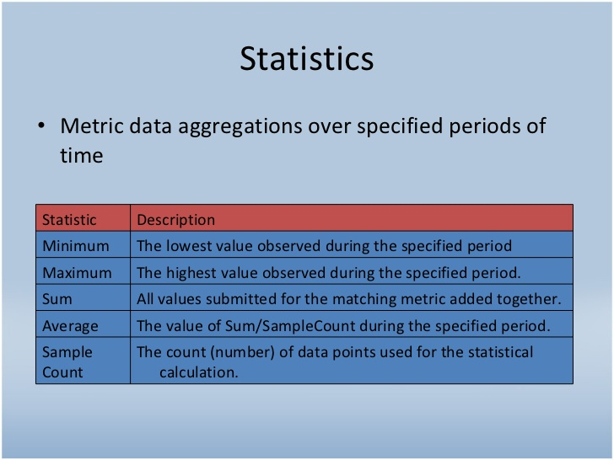

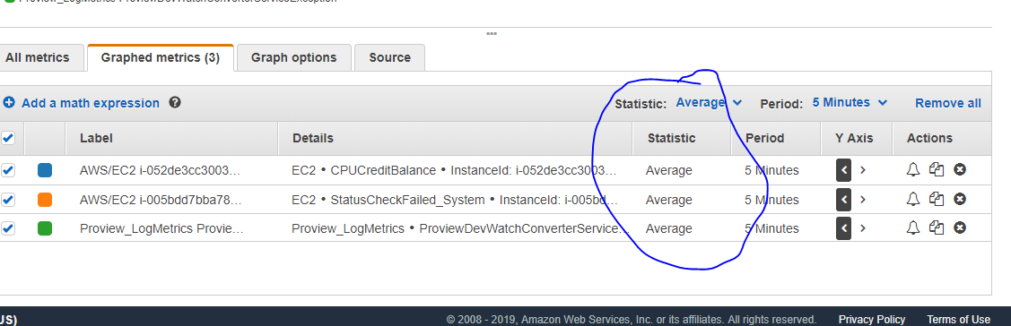

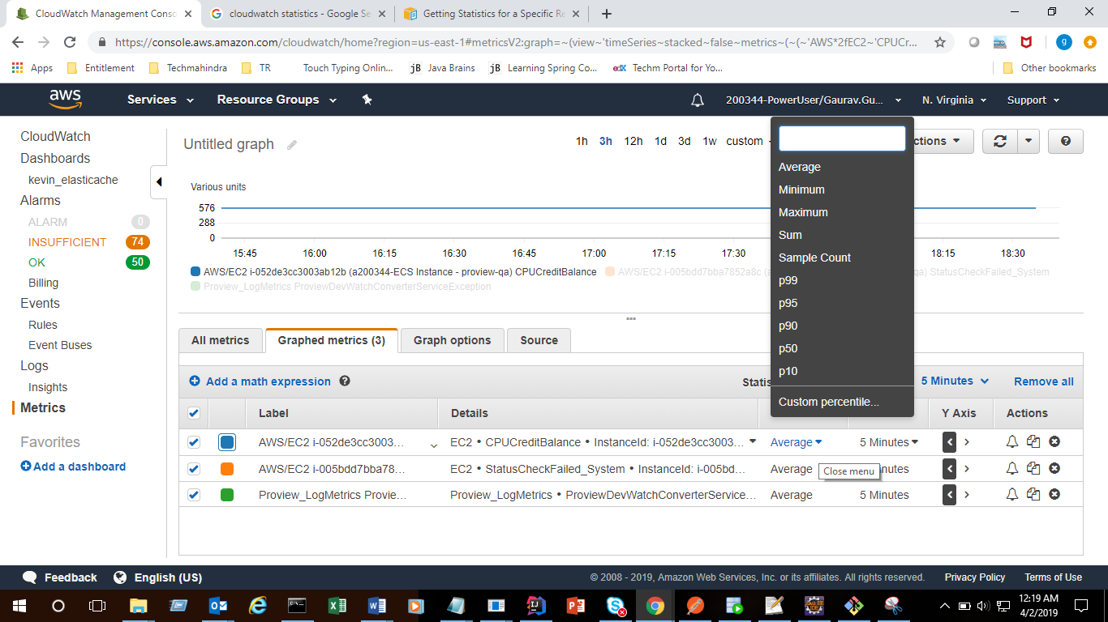

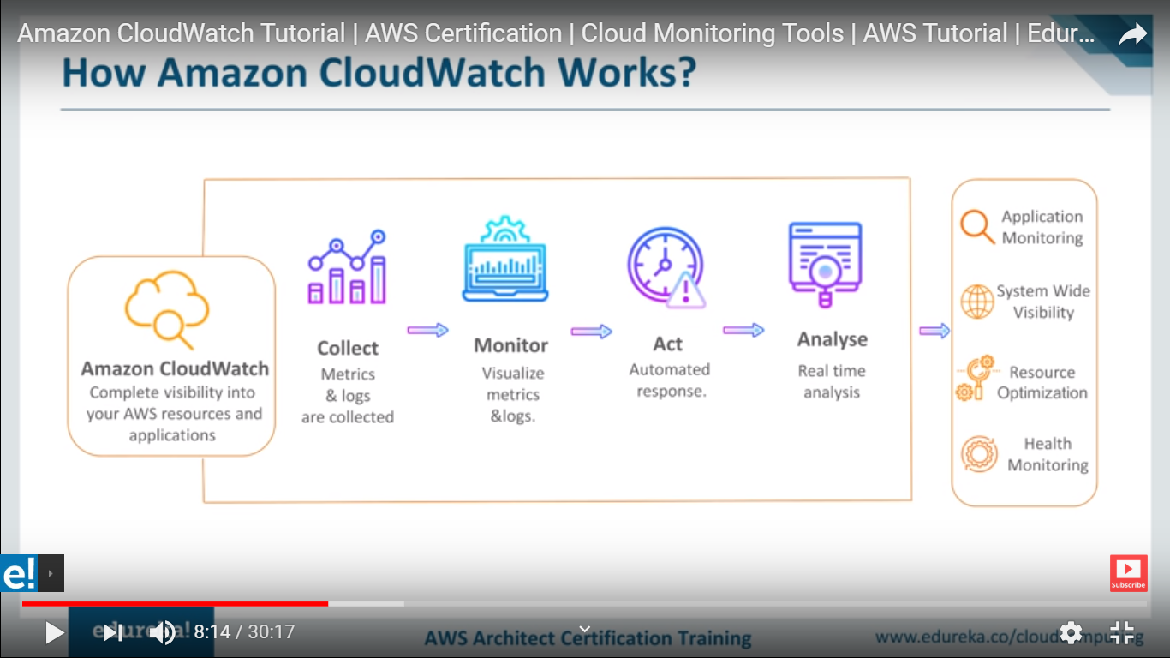

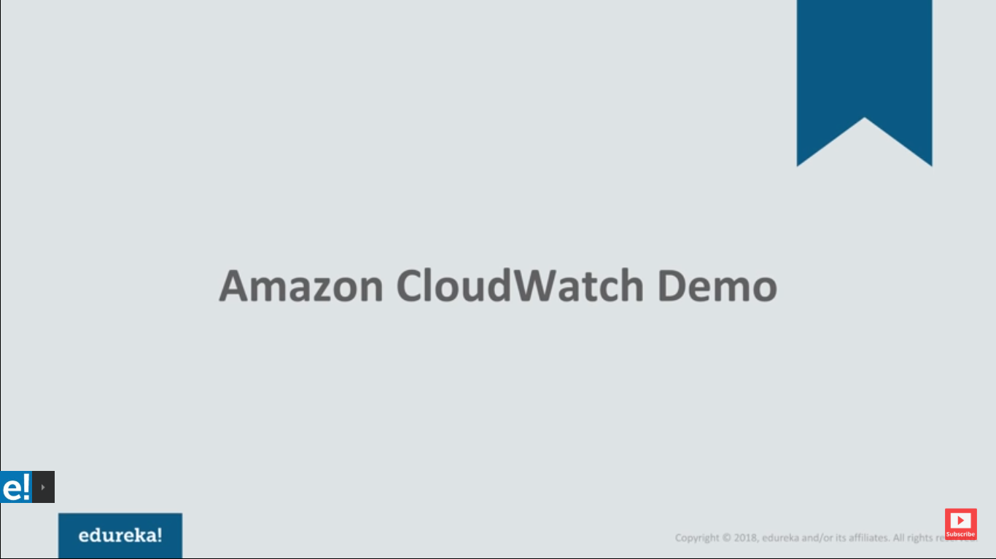

**How to create cloud watch :For getting Notification Create a topic and**

**Subscribe to mail Id**

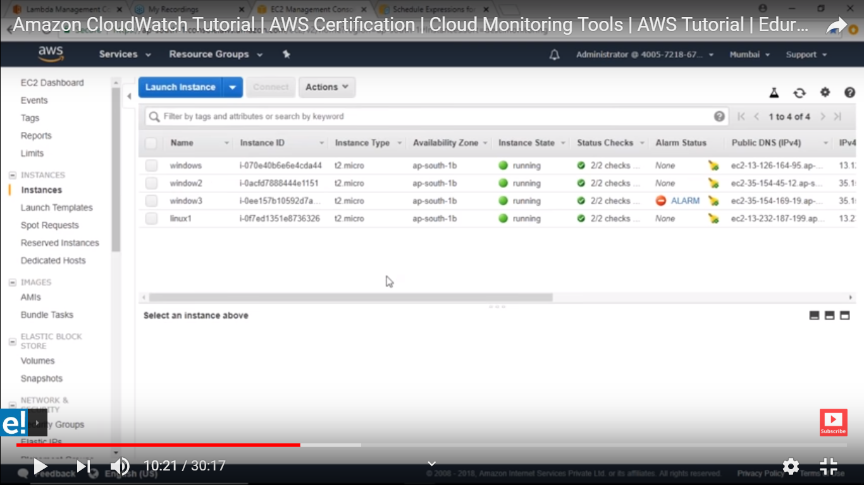

**Click on Simple Notification service :**

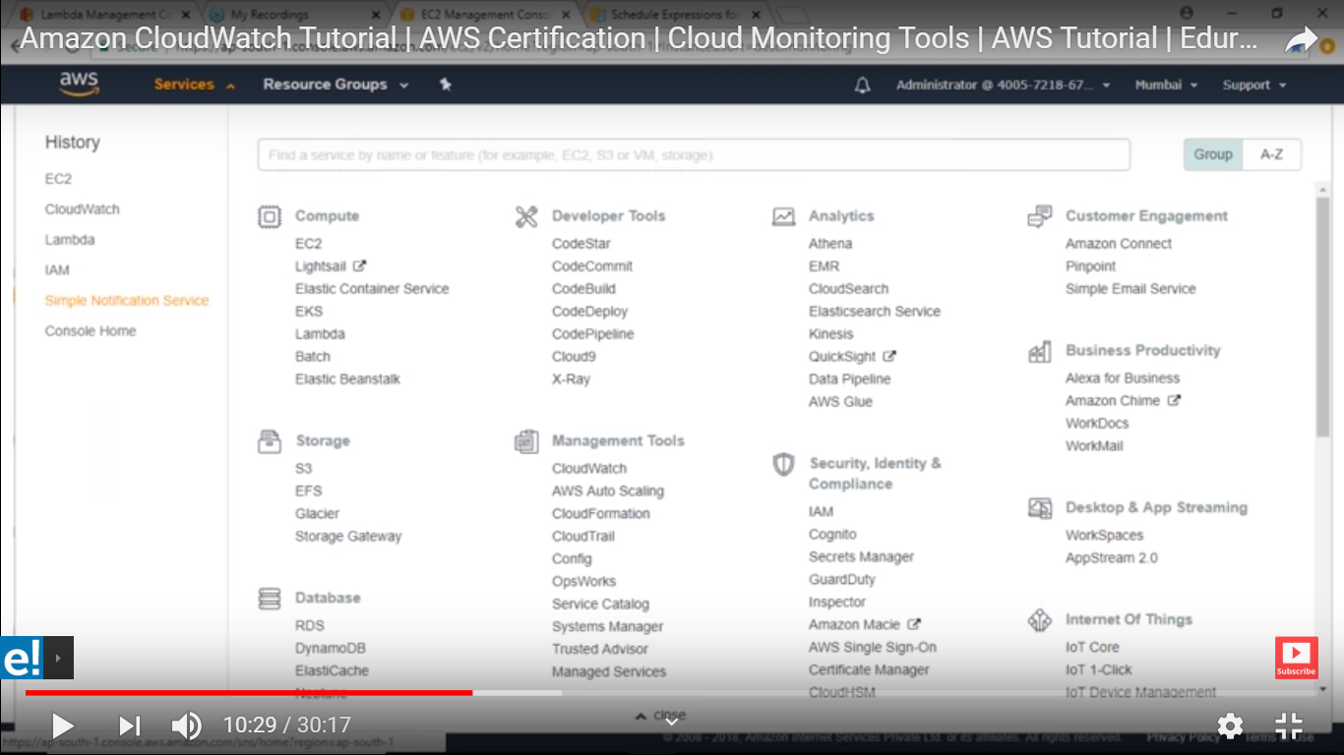

**Create a topic :**

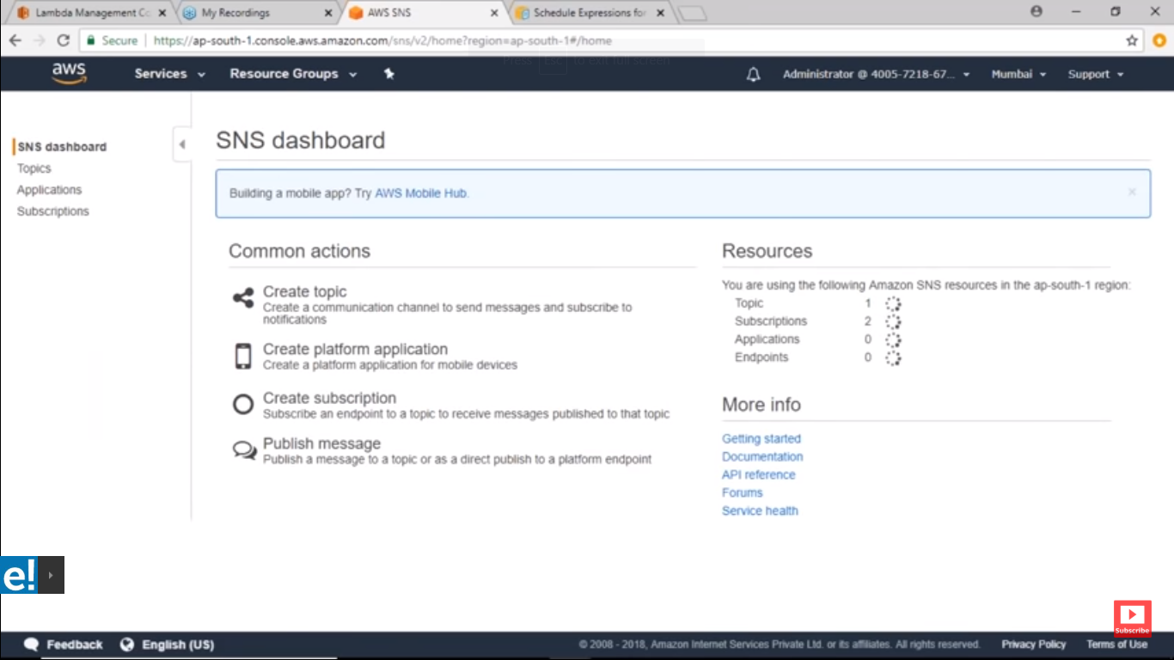

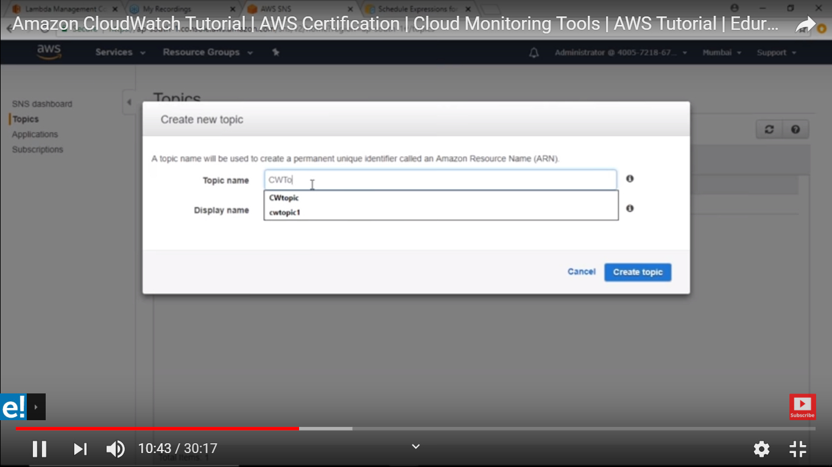

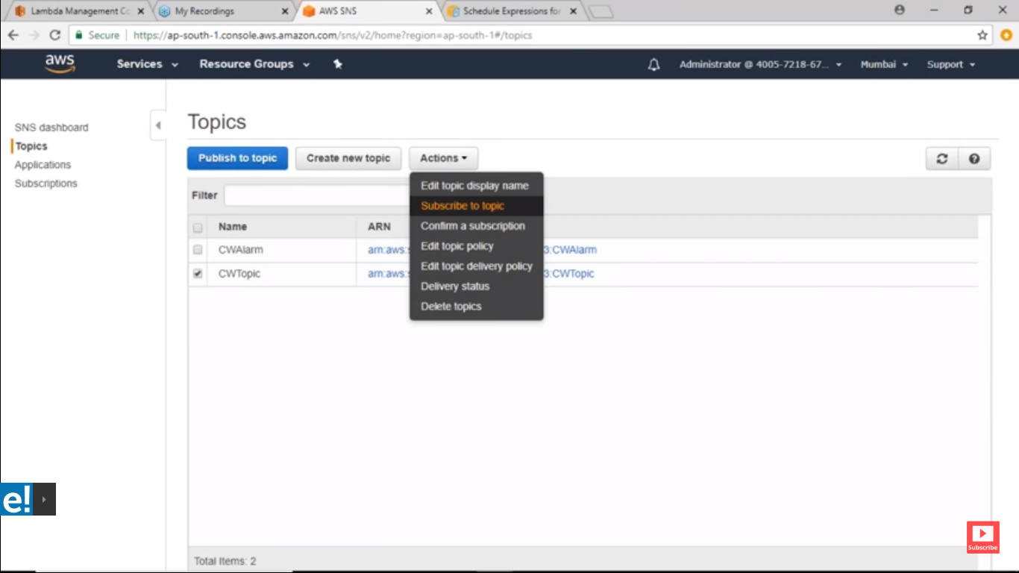

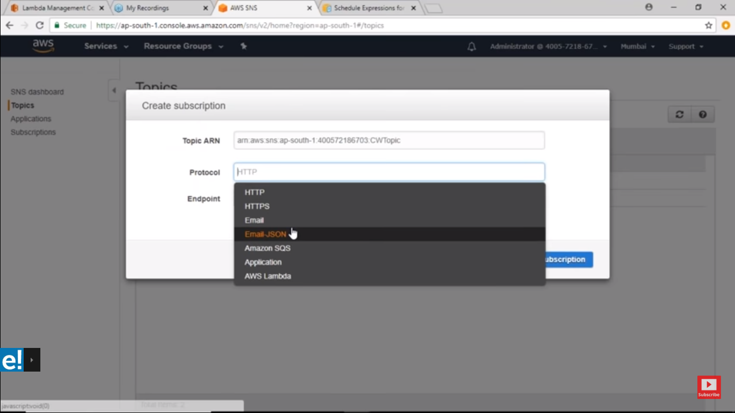

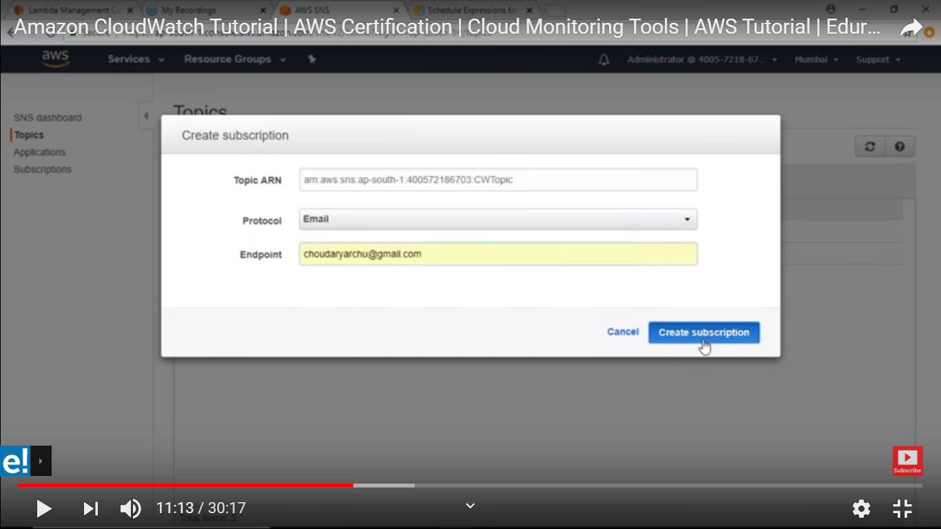

**Now go to cloudwatch dash board :**

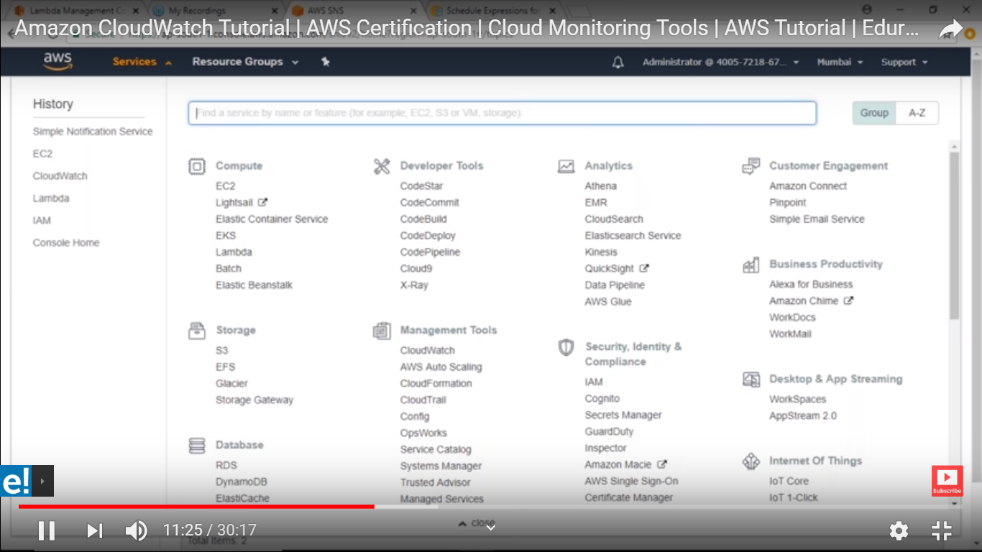

**Select metric option :**

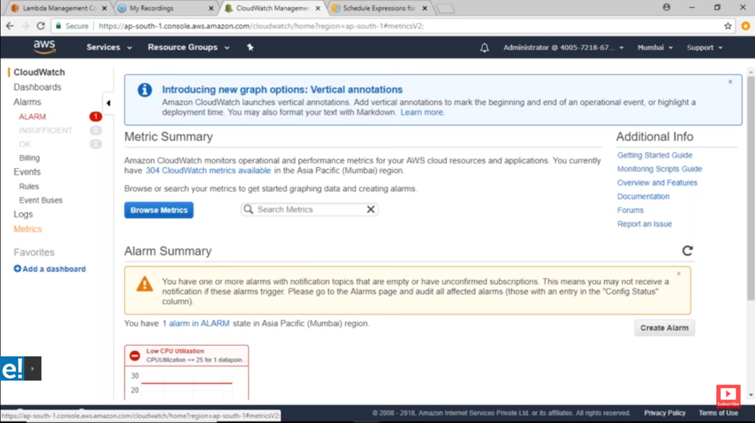

**Then choese EC2:**

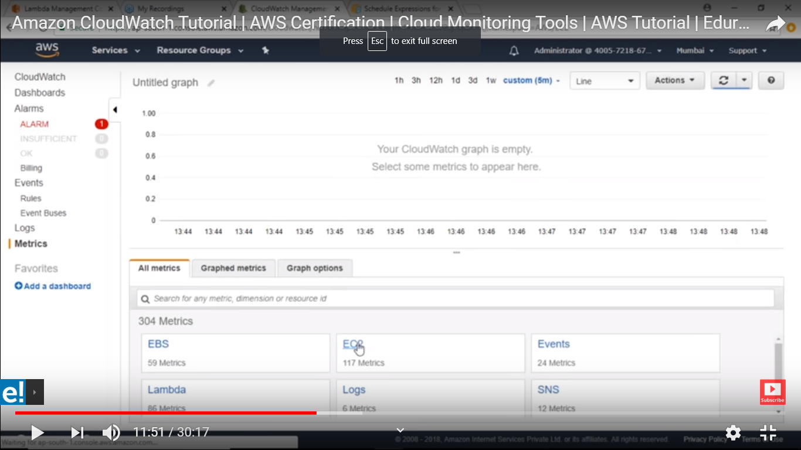

**Then per-instance metrics :**

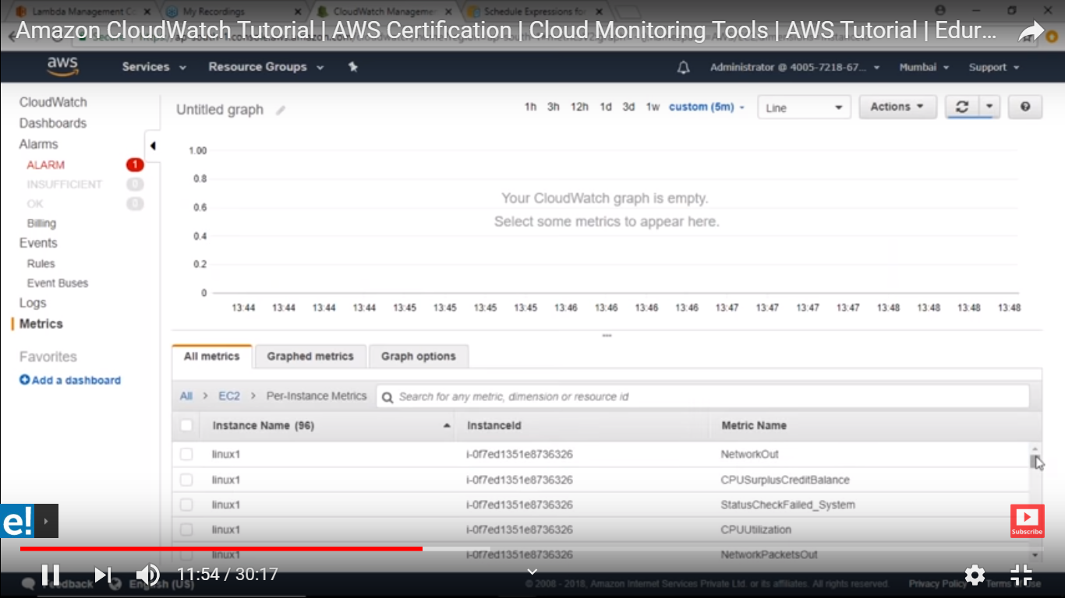

**You can search based on metric name like cpuutilzation here**

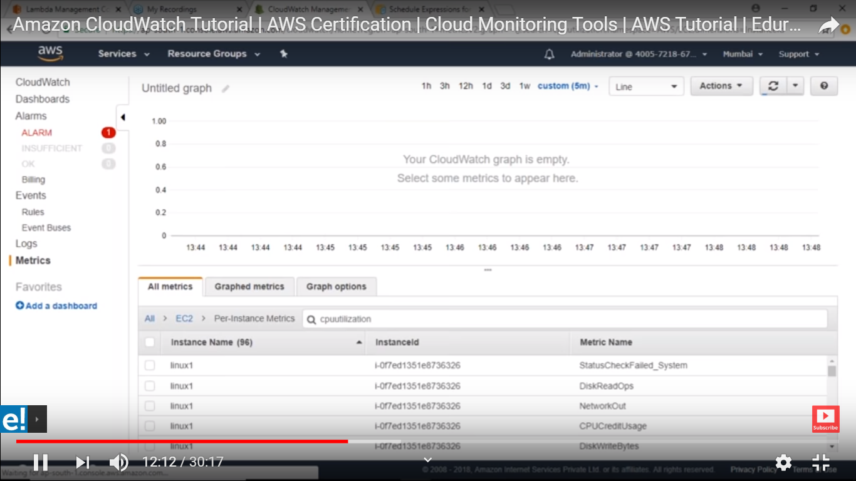

**Chose one of them and chose graph metric :**

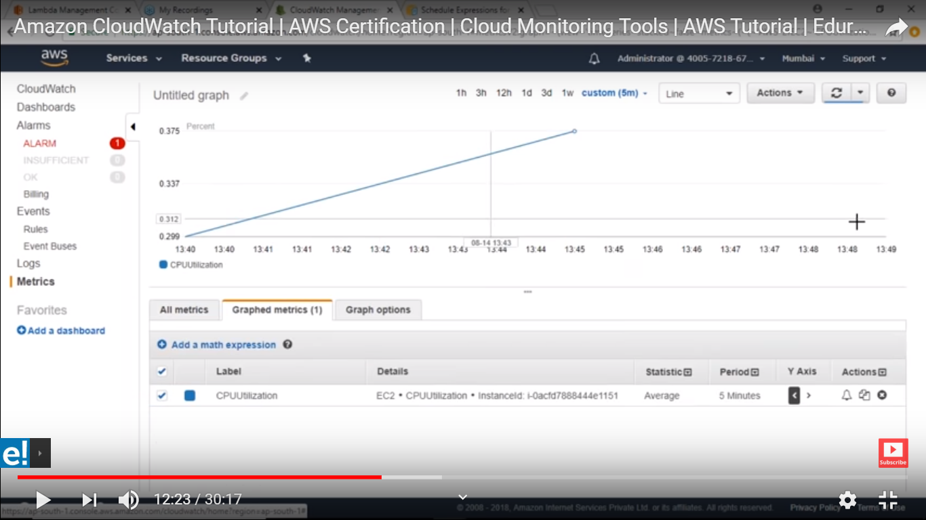

**On right side you can see alarm button and you can create from here :**

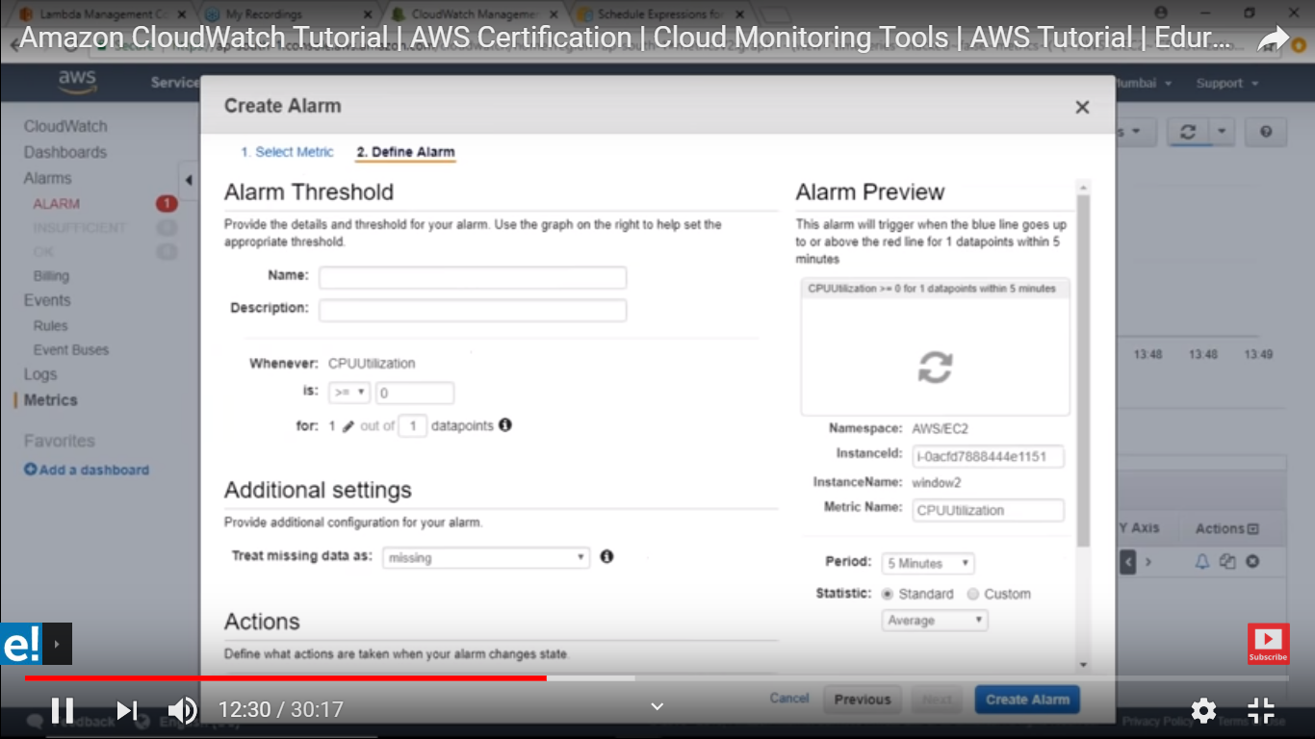

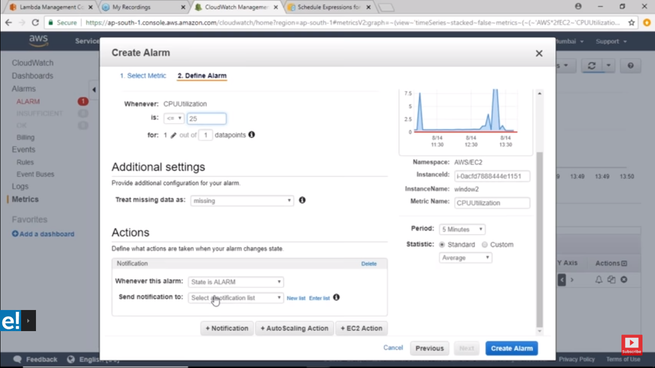

**Send notification chose which you have create the topic**

**Period is default here for 5 min you having detail monitoring that will be 1 min .**

**Here you can see you are created Alarm by clicking them you can see complete description about this**

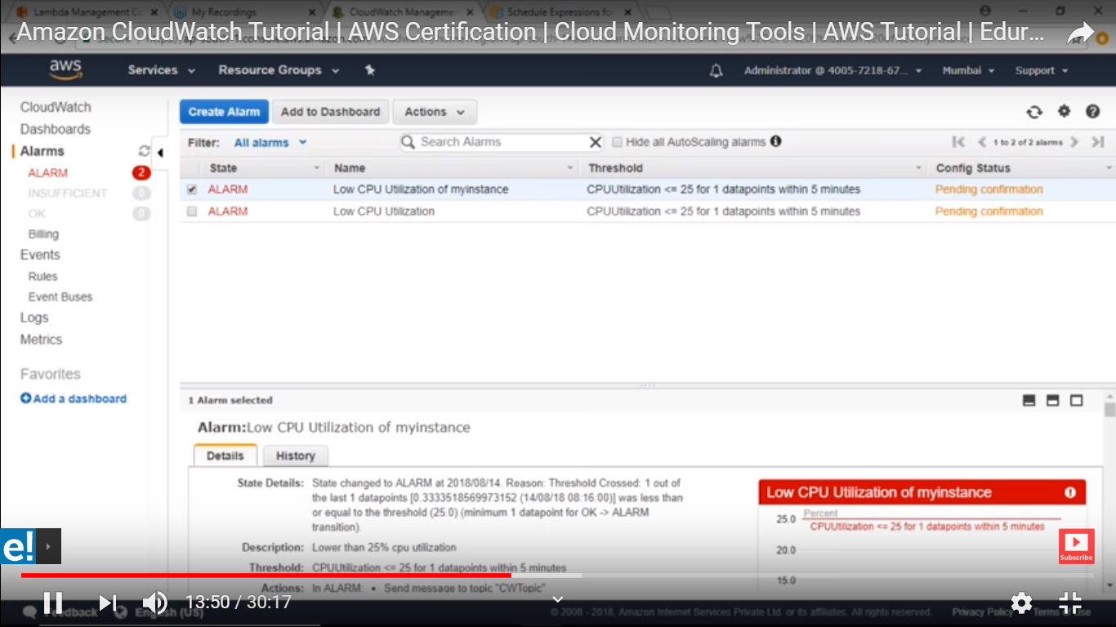

**Imp :**

Some important monitoring

**<----------------AWS ELB monitoring------------->**

**Application Load Balancer Metrics (namespace AWS/ApplicationELB) for load balancers.**

1. Latency

2. HTTP\_Redirect\_Count

3. HTTPCode\_ELB\_3XX\_Count

4. HTTPCode\_ELB\_4XX\_Count

5. HTTPCode\_ELB\_5XX\_Count

6. NewConnectionCount

7. RejectedConnectionCount

8. RequestCount

**Application Load Balancer Metrics (namespace AWS/ApplicationELB) for targets.**

1. UnhealthyHost

2. healthyHost

3. HTTPCode\_Target\_2XX\_Count

4. HTTPCode\_Target\_3XX\_Count

5. HTTPCode\_Target\_4XX\_Count

6. HTTPCode\_Target\_5XX\_Count

7. RequestCountPerTarget

8. TargetConnectionErrorCount

9. TargetResponseTime

**Application Load Balancer Metrics (namespace AWS/ApplicationELB) for Lambda functions that are registered as targets.**

1. LambdaInternalError

2. LambdaUserError

**Application Load Balancer Metrics (namespace AWS/ApplicationELB) for user authentication.**

1. ELBAuthError

2. ELBAuthFailure

3. ELBAuthLatency

4. ELBAuthSuccess

<------------- EC2 Metric----------->

1. Disk I/O metrics

2. Network metrics

3. CPU metrics

4. Status check

------------------------------------------------------------------------------------------------------------------------------------------**What we have an existing and we need to check all others also (same dimensions) are covered**

Existing Metrics :=>

**Metric Name**

1. UnHealthyHostCount ------------> UnHealthyHostCount

2. 5XXError ------------> covered 2 API Gateway

3. ConsumedReadCapacityUnits ------------> on DynamoDB

4. ConsumedWriteCapacityUnits ------------> on DynamoDB

5. CPUReservation ------------> on ECS

6. CPUUtilization ------------> on EC2 and RDS

7. DatabaseConnections ------------> on RDS

8. FreeStorageSpace ------------> on RDS

9. GroupInServiceInstances ------------> on AutoScaling

10. HealthyHostCount ------------> on ELB

11. HTTPCode\_Target\_XXX\_Count ------------> on AWS/ApplicationELB

12. Latency ------------> on 2 AWS/ApiGateway

13. MemoryReservation ------------> on ECS

14. ProviewDevWatchConverterServiceException --------> on Proview\_LogMetrics

15. ProvisionedReadCapacityUnits --------> on AWS/DynamoDB

16. ProvisionedWriteCapacityUnits --------> on AWS/DynamoDB

17. ReadLatency --------> on RDS

18. StatusCheckFailed ------------> on EC2

19. SurgeQueueLength ------------> on AWS/ELB

20. TargetResponseTime ------------> on AWS/ApplicationELB

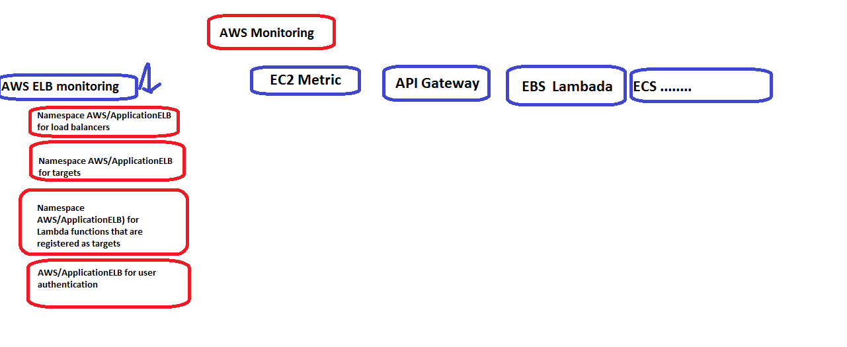

# **12 Top Things to Monitor in Amazon EC2**

Amazon’s Elastic Compute Cloud (EC2) is one of the most popular products on Amazon Web Services (AWS), used by 84% of companies on AWS according to 2nd Watch’s [***2015 AWS Scorecard***](http://2ndwatch.com/blog/peek-inside-companies-using-amazons-6-billion-cloud/). Amazon EC2 provides the foundation for many organizations’ cloud strategies, enabling teams to allocate compute resources rapidly and easily meet demand at both high and low points for truly web-scale performance. Companies like **[Stormpath](http://searchaws.techtarget.com/opinion/AWS-architects-expect-private-cloud-to-live-on-cite-security-other-risks" \t "_blank)** and **[Tapjoy](https://aws.amazon.com/solutions/case-studies/tapjoy/" \t "_blank)** rely on EC2 to run their production systems in an efficient and reliable way.

However, monitoring all the metrics for a production compute cluster still remains a significant challenge. Despite EC2’s resilience and elasticity, there are still ongoing objectives that require close tracking of capacity, predictability, and interdependence with other services and infrastructure. Similar to our review of [**Amazon RDS top metrics**](https://www.signalfx.com/blog/10-top-things-to-monitor-in-amazon-rds/), here are the top indicators you should monitor for insights into availability, performance, and cost.

### Availability

You need to know quickly when there’s an outage in your production servers. Outages can cause degraded user experience and, potentially, lost revenue.

##### Instance State and Health

If you have several instances in your production cluster, you should be aware of whether each instance is healthy or not. Amazon has the ability to track if each instance is in the running state, as shown in the screenshot below. A better health indicator will say if instances are responding to requests in an expected time and without errors.

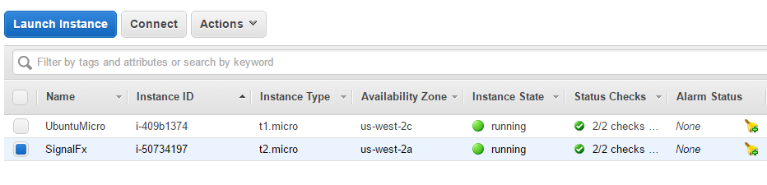

##### Status Checks

Amazon performs status checks on all EC2 servers by default. They come in two flavors: system status checks and instance status checks. System status checks monitor conditions that require AWS’s involvement to fix, including loss of network connectivity and hardware issues. Instance status checks monitor conditions that you need to fix yourself, including exhausted memory and corrupt file system. The best practice is to set a status check alarm to notify you when a status check fails.

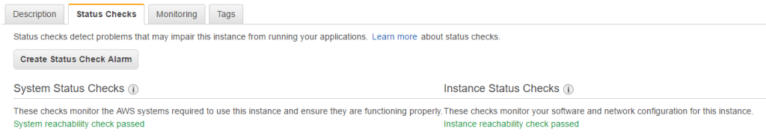

##### Resource Starvation

Servers can become unavailable when the resources that they need to support clients are exhausted. For example, web servers can become unresponsive when they lack sufficient CPU or memory to respond before timing out. If a server does not even have enough memory to support an incoming SSH connection, you will not be able to access it through a remote terminal. In this case, you’ll need to do a hard reboot, which risks losing the system state. A good monitoring system will store metrics from the instance and can show you an increase in its resource usage until eventually hitting a ceiling and becoming unavailable.

##### System Errors

System errors can also cause your instance to become unavailable or fail a status check. You can find these errors listed inside your system log file, which is often in /var/log/syslog or /var/log/messages. You might see problems with boot up or kernel errors. You can aggregate these logs to Amazon CloudWatch Logs by installing their agent, or you can use syslog to forward the logs to some other central location.

##### Human Errors

Sometimes, especially in large teams, people can make changes that can impact service availability. For example, a misconfigured security group could make your instance unreachable, or an auto-scaling script could accidentally remove too many instances and make your service unavailable. You can find a record of all the changes made using the AWS API or console through the CloudTrail audit log. If you suspect an outage is due to changes made by a person or automated tool, this is the first place to look.

### Performance

Performance impacts user experience and, therefore, impacts earnings. For web applications, slow page load times will lead users to abandon the page, some never to return. The performance of the server you’re running on underlies and determines application performance. It’s important to continuously monitor system performance because it is often most affected during bursts of activity or periods of peak demand. You’ll also want to drill down into performance data across several dimensions to determine the root cause of problems and address bottlenecks.

Turning on CloudWatch metrics monitoring for your instances gives you access to the data you need to optimize performance, as shown in the screenshot below:

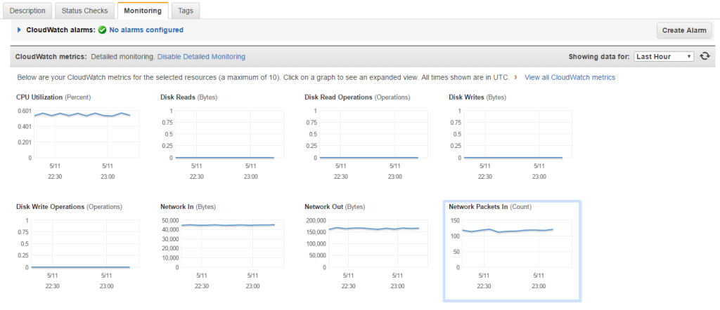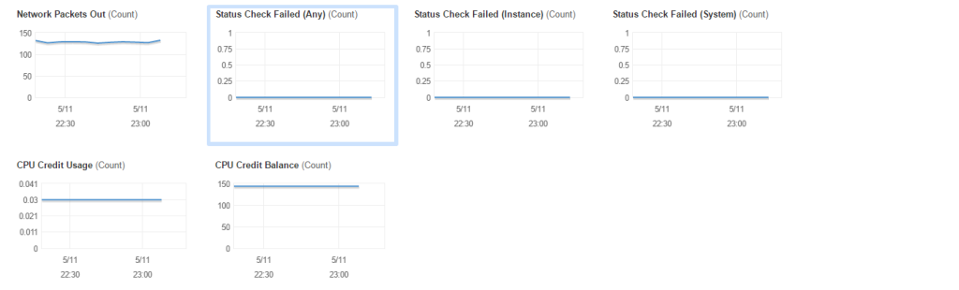

##### CPU Usage

CPU usage is shown as a percentage for each instance. If you are hitting a CPU limit on a shared instance, you might want to check out your CPU credit balance as shown in the CloudWatch dashboard above. Additionally, you should check the CPU steal time to see whether other VMs on the shared instance are using up the CPU. CloudWatch doesn’t store this metric, so you’ll need to check it on the box, either directly or using an agent such as collectd. If you find consistently high steal time, you might benefit from switching to a different instance that might be more lightly loaded. If that doesn’t produce appreciable results, consider shelling out for a dedicated instance.

##### Disk Usage

CloudWatch makes your disk throughput and I/O operations per second (IOPS) data available, but you’ll have to log directly into the box or use collectd to check your disk usage. Even if you are using less than the full disk space, you might be hitting a ceiling on IOPS or volume throughput.

##### Network Usage

It’s easy to keep track of your network usage, including throughput and total number of packets. Instances have a limit on the throughput based on the instance type, so upgrading to a larger instance could improve your network performance. It’s also easy to overlook dependencies between resources. For example, using Elastic Block Storage (EBS) volumes can also increase your network usage.

##### Application Performance

Monitoring system performance on EC2 is a good start, but the most important metrics often come from applications because these are most closely tied to user experience. Examining your system and application performance together and finding any correlation between the two can give you clues to the root cause of a problem and how to optimize your resource usage.

CloudWatch does not offer a way to monitor application performance by default. You have to instrument your application to output metrics, and then use an agent or collector to receive and process them. CloudWatch does offer a way to forward custom events, but it does not offer specific integrations for popular servers or applications. A better approach is to use a standard agent such as collectd, which offers the ability to monitor widely-used technologies like Apache, Nginx, Java, and many more. To learn more about application performance management, [**click here**](https://support.signalfx.com/hc/en-us/articles/204457945).

### Cost Management

Moving to larger instances or adding additional instances is an easy short-term solution to performance and availability issues. However, this can create problems with costs over the long run. Even a small increase in cost can become compounded and add up over time. Moreover, changes in the business or application can change the need for those instances, resulting in them being forgotten as projects and employees move on, or being left as technical debt that directly affects the bottom line.

##### Instance Type

When you hit a performance bottleneck, one of the easiest things to do is switch to a larger instance. The reality is that you can only do this so many times before reaching the largest instance size on offer, or spending so much it affects your operating margin.

Thankfully, you can save money by using lower-cost options including reserved instances, on-demand instances, or spot instances. Additionally, you may be able to use smaller instances by scaling horizontally instead of vertically. Keep an eye on how many instances you have of each type, and make sure that those expensive on-demand instances don’t stick around longer than they have to.

##### Instance Count

Scaling systems horizontally is another good way to grow. However, large clusters also take more operational effort to maintain because distributed systems are more complex. A common approach is to take advantage of Amazon Elastic Load Balancer (ELB) or Amazon Route 53 to distribute load across multiple instances and set up auto-scaling rules that add capacity as needed. [Note: ELB uses a proxy approach to load balancing, and Route 53 uses a DNS round robin approach.]

You can use scripts that automatically scale your infrastructure on-demand to match requirements. For example, if you hit a CPU threshold as monitored in CloudWatch, you can run the script, add instances, and update your proxies with the new node.

On the other hand, auto-scaling opens you up to serious risk if some kind of bug or error causes infrastructure to to spin up continuously. For example, if you tie auto-scaling to your CPU usage, and a bug causes your services to spin at 100% CPU, you may wake up the next morning to find a big AWS bill. That’s why a reliable monitoring solution is so important—it can alert you to problems like this before it’s too late.

##### Network and Storage Costs

Network and storage add to the price you pay for an EC2 instance. While you can easily see your network usage for a specific instance in CloudWatch metrics, it’s not so easy to see this quantity aggregated across all your instances. It’s even more difficult to see storage usage because it’s not tracked in CloudWatch. This includes your usage based on the volumes for each instance, as well as your snapshots, and even volumes that are not attached to instances. Remember that using EBS-backed volumes will use network capacity, as well.

### Challenges of Monitoring

Amazon Cloudwatch makes monitoring your EC2 instance much easier, but it’s not a complete solution. There’s a variety of other data sources about your EC2 instances, including CloudWatch Logs, CloudTrail, and the Cost Explorer. You probably also want to track additional information from your instances, including from collectd, system logs, on-prem systems, and applications. Your ideal monitoring solution will offer integrations to aggregate data from many different sources.

Furthermore, many of the solutions that Amazon provides offer limited analytics support. In CloudWatch metrics, you can only plot the metrics it offers. It lacks the ability to derive or calculate new fields, to look for specific patterns of repeating behavior, or predict problems before they become critical. For CloudWatch Logs and CloudTrail, there is no visualization or analytics support.

Just last year, Amazon launched support for the Elasticsearch service with Kibana, which can help you analyze your log data. For real-time metrics monitoring, you’ll want to consider something more powerful but still easy to use like SignalFx.

### Using SignalFx

SignalFx provides [**real-time cloud monitoring**](https://www.signalfx.com/solutions/cloud-monitoring/) for CloudWatch metrics, your applications, and on-prem systems. It offers native [**integrations with metrics**](https://www.signalfx.com/solutions/metrics/) to monitor all of your microservices so you don’t have to build your own. It also offers analytics, allowing you to predict problems before they become critical, and provides [**meaningful alerts**](https://www.signalfx.com/solutions/alerting/) that you can act on right away.

[**In part two of this blog series**](https://www.signalfx.com/blog/monitoring-amazon-ec2-with-signalfx/), you’ll learn how SignalFx gives you insight into the current state of your [**Amazon EC2**](https://www.signalfx.com/amazon-ec2-monitoring/) instances so you can easily monitor availability and performance, as well as manage costs.

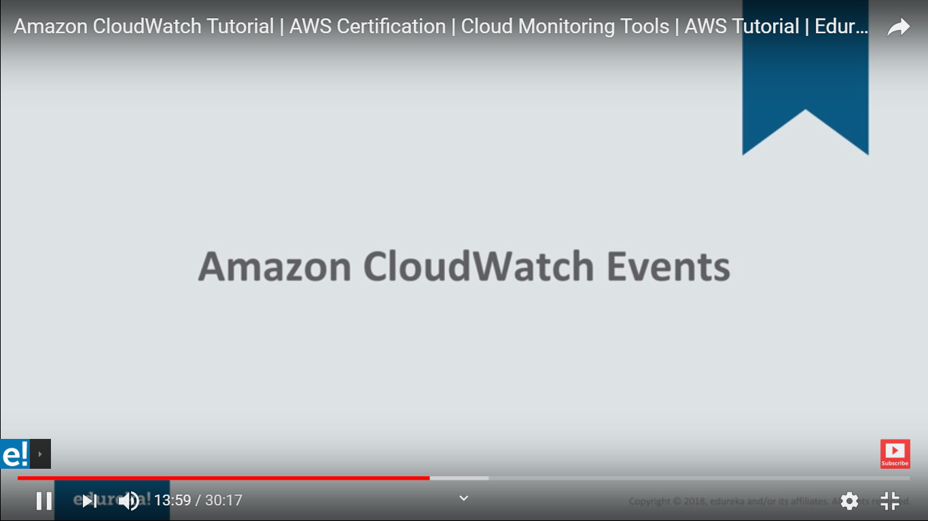

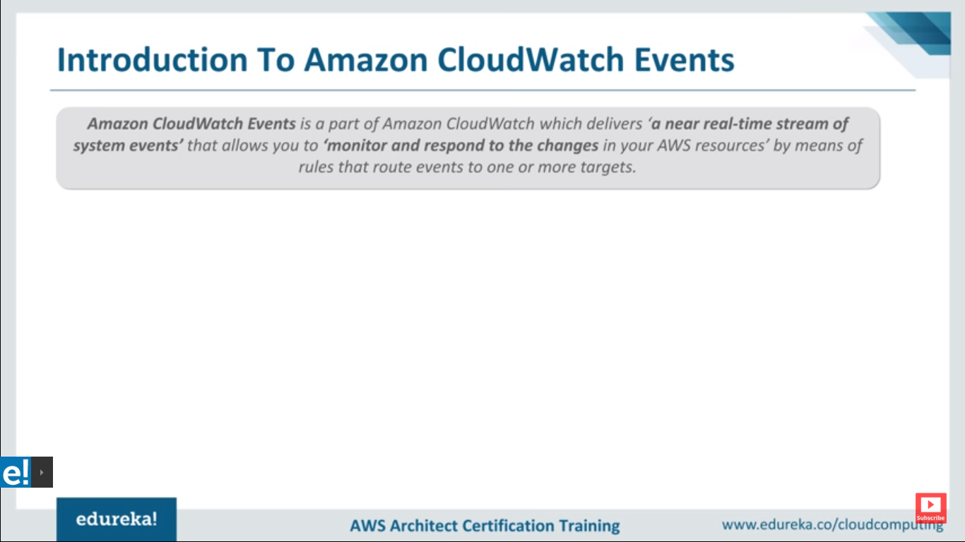

**Amazon cloudwatch Event will help you in this scenario:**

**Suppose you have autoscaling group and in an instance some instance are terminated then this event will trigger and this will send you notification**

Before you begin using CloudWatch Events, you should understand the following concepts:

* **Events**—An event indicates a change in your AWS environment. AWS resources can generate events when their state changes. For example, Amazon EC2 generates an event when the state of an EC2 instance changes from pending to running, and Amazon EC2 Auto Scaling generates events when it launches or terminates instances. AWS CloudTrail publishes events when you make API calls. You can generate custom application-level events and publish them to CloudWatch Events. You can also set up scheduled events that are generated on a periodic basis. For a list of services that generate events, and sample events from each service, see [CloudWatch Events Event Examples From Supported Services](https://docs.aws.amazon.com/AmazonCloudWatch/latest/events/EventTypes.html).
* **Targets**—A target processes events. Targets can include Amazon EC2 instances, AWS Lambda functions, Kinesis streams, Amazon ECS tasks, Step Functions state machines, Amazon SNS topics, Amazon SQS queues, and built-in targets. A target receives events in JSON format.
* **Rules**—A rule matches incoming events and routes them to targets for processing. A single rule can route to multiple targets, all of which are processed in parallel. Rules are not processed in a particular order. This enables different parts of an organization to look for and process the events that are of interest to them. A rule can customize the JSON sent to the target, by passing only certain parts or by overwriting it with a constant.

# What is Amazon CloudWatch Events?

Amazon CloudWatch Events delivers a near real-time stream of system events that describe changes in Amazon Web Services (AWS) resources. Using simple rules that you can quickly set up, you can match events and route them to one or more target functions or streams. CloudWatch Events becomes aware of operational changes as they occur. CloudWatch Events responds to these operational changes and takes corrective action as necessary, by sending messages to respond to the environment, activating functions, making changes, and capturing state information.

You can also use CloudWatch Events to schedule automated actions that self-trigger at certain times using cron or rate expressions. For more information, see [Schedule Expressions for Rules](https://docs.aws.amazon.com/AmazonCloudWatch/latest/events/ScheduledEvents.html).

You can configure the following AWS services as targets for CloudWatch Events:

* Amazon EC2 instances
* AWS Lambda functions
* Streams in Amazon Kinesis Data Streams
* Delivery streams in Amazon Kinesis Data Firehose
* Amazon ECS tasks
* Systems Manager Run Command
* Systems Manager Automation
* AWS Batch jobs
* Step Functions state machines
* Pipelines in CodePipeline
* CodeBuild projects
* Amazon Inspector assessment templates
* Amazon SNS topics
* Amazon SQS queues
* Built-in targets—EC2 CreateSnapshot API call, EC2 RebootInstances API call, EC2 StopInstances API call, and EC2 TerminateInstances API call.
* The default event bus of another AWS account

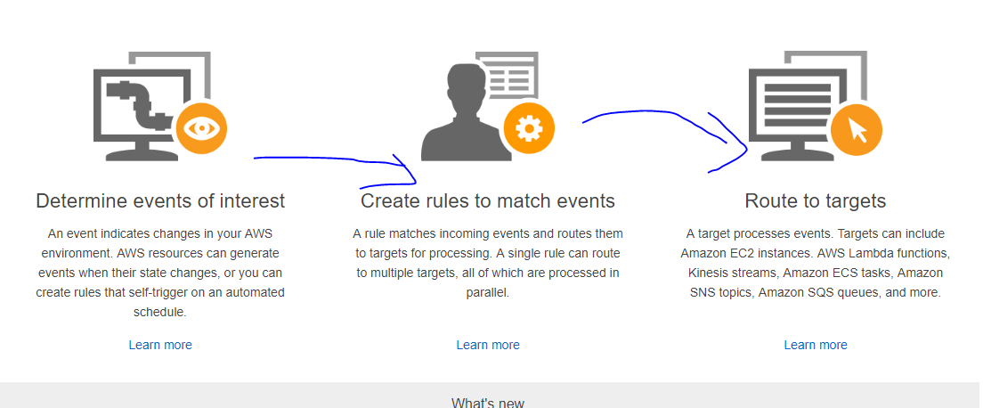

**Note : Metrics are report of running AWS resources and Events are state change in resources**

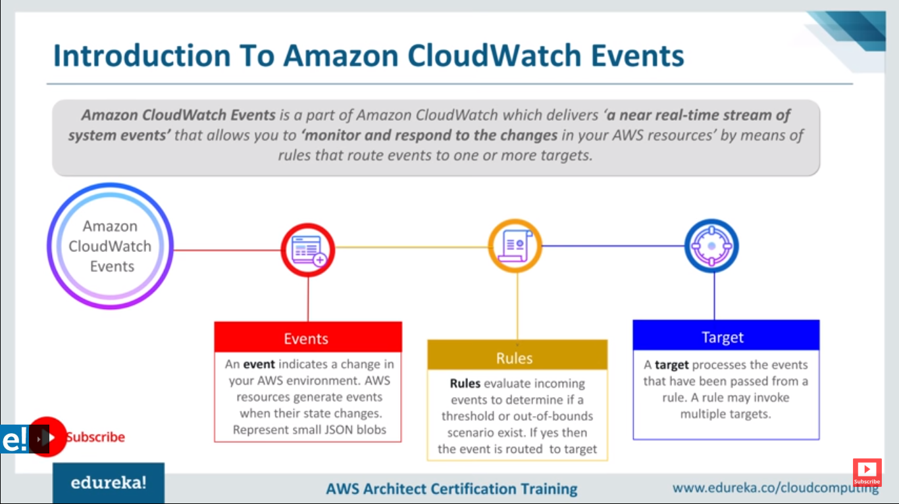

**Target can be SNS and Lamda**

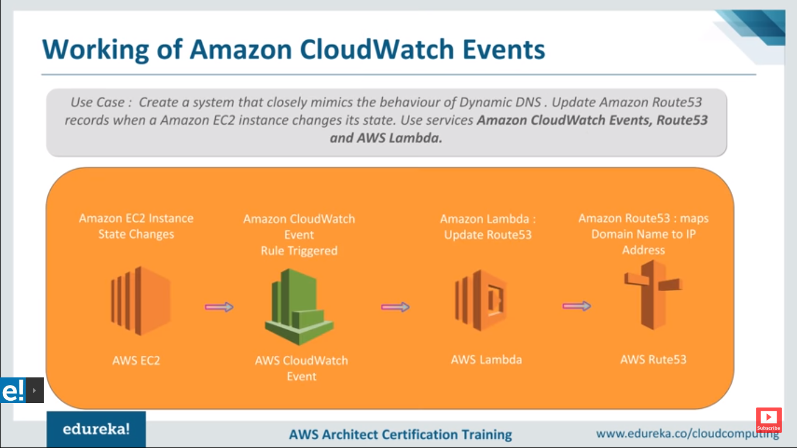

**Dynamic DNS : If you are using home internet for that service provider will gives you Ip address this address is keep changing what Dynamic DNS does it it provide custom domen name to your home IP address so this domain name will automatically update when your home ip address is change So here**

**Route 53 work same like**

**Use case : If you delete EC2 instance it will trigger AWS Colud watch Event and trigger Lamda and delete the record on Route53**

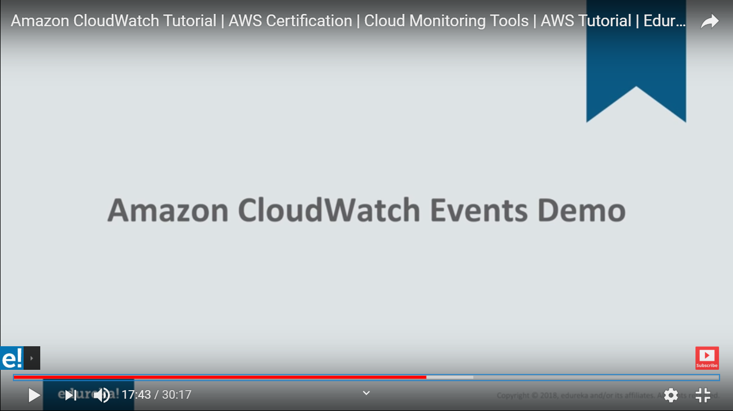

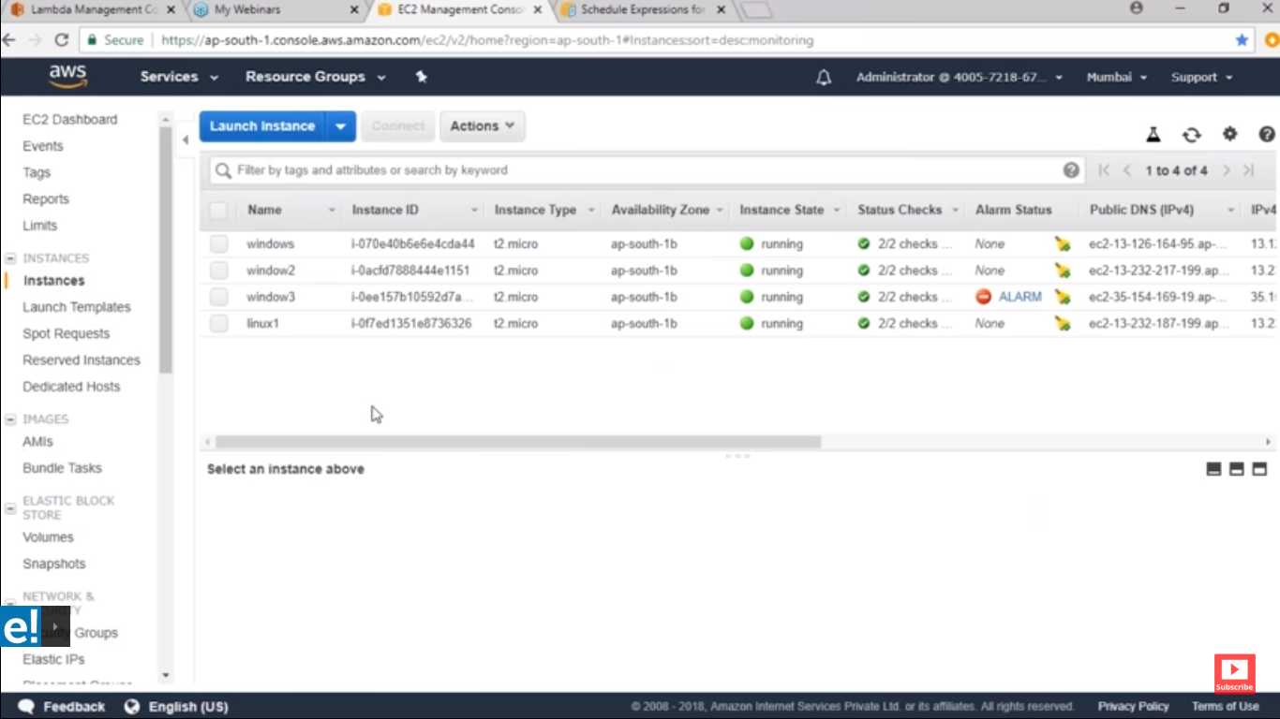

**Create Lambda function if you create lambda you need permission so for that u can use service IAM where u can assign a permission**

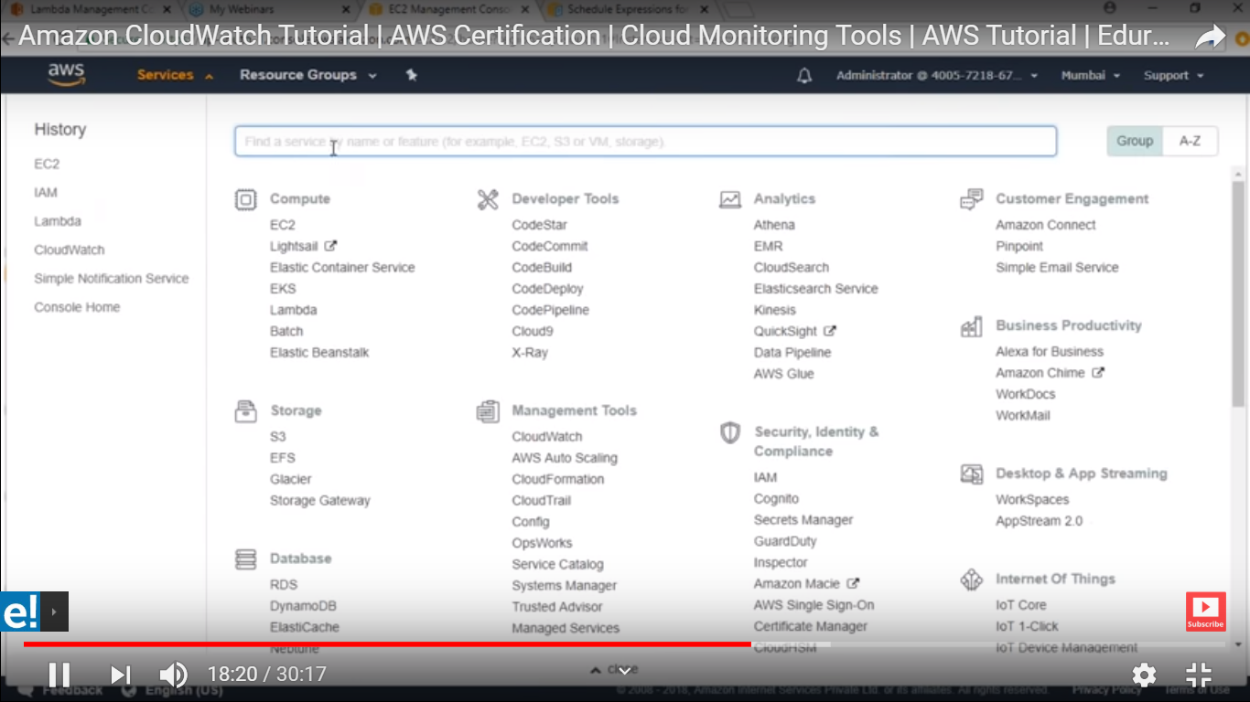

**Select Polcy :**

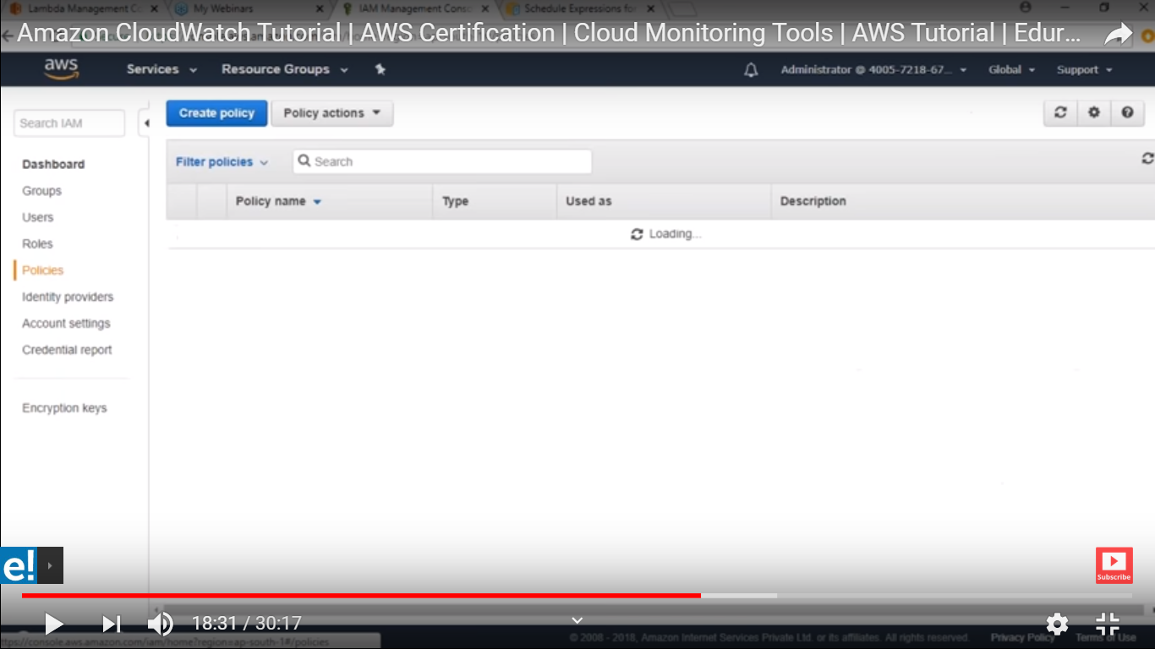

**Create polcy :**

**Service is EC2 etc**

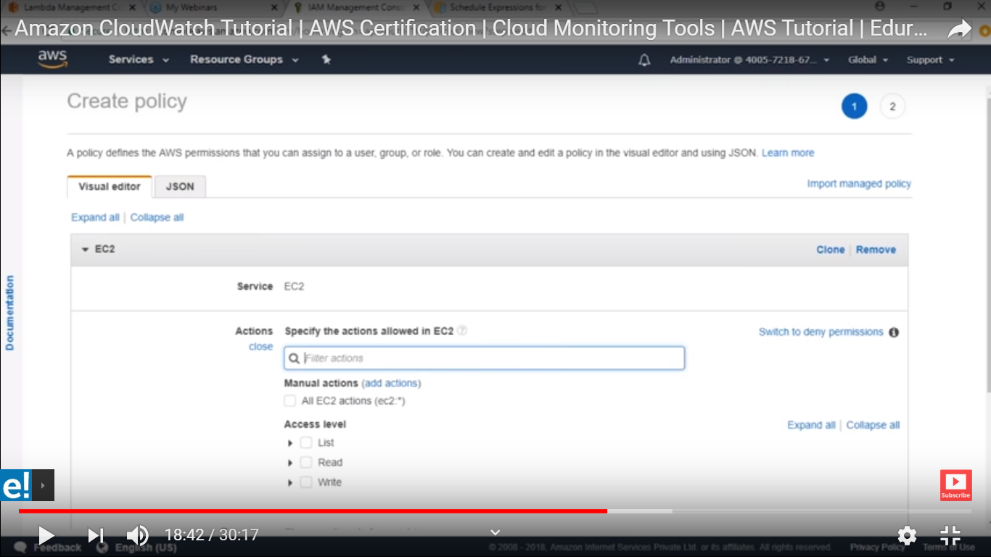

**Action are predefine function**

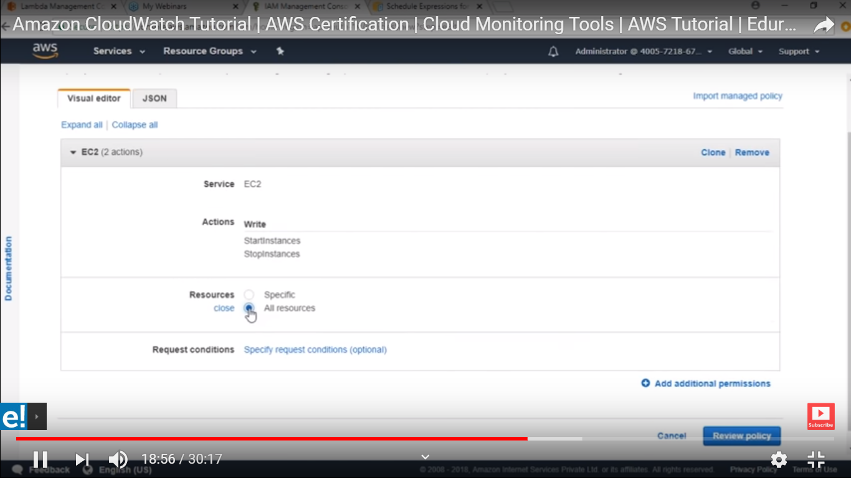

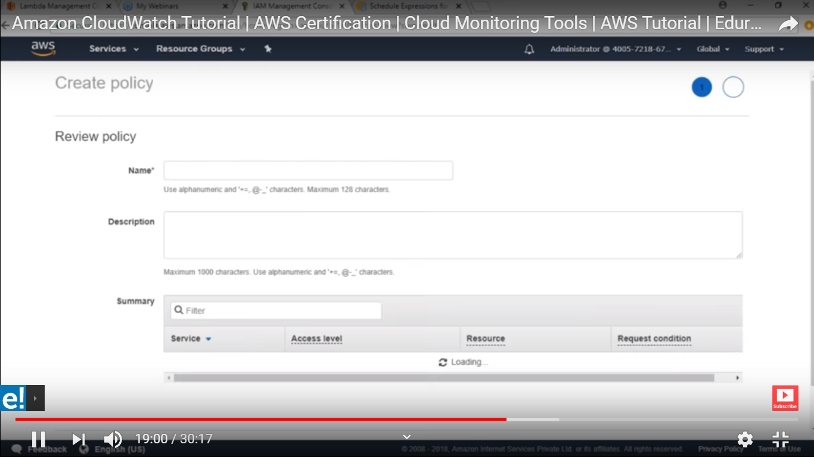

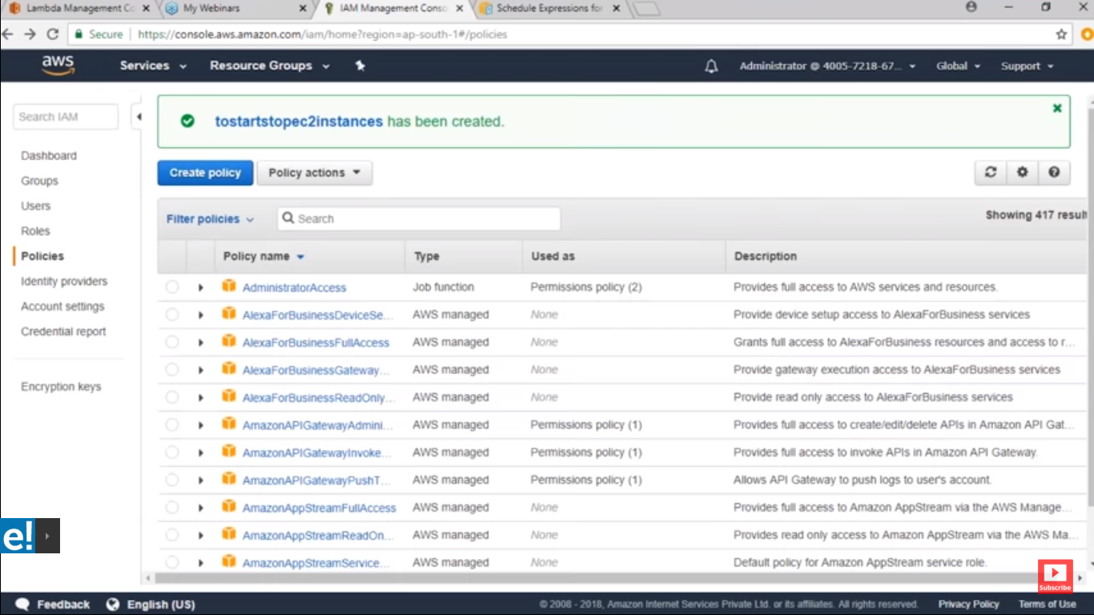

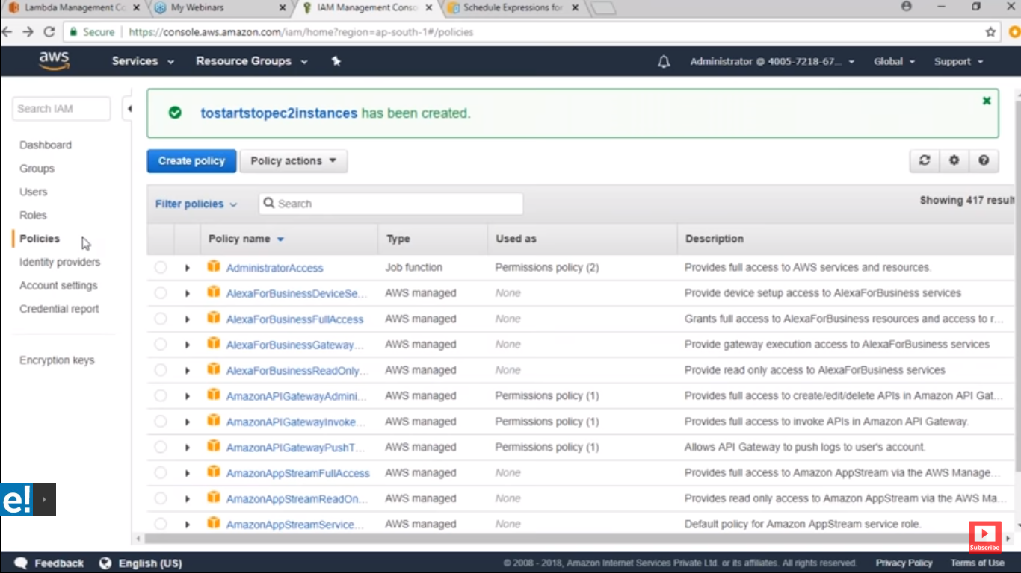

**Click on Role :**

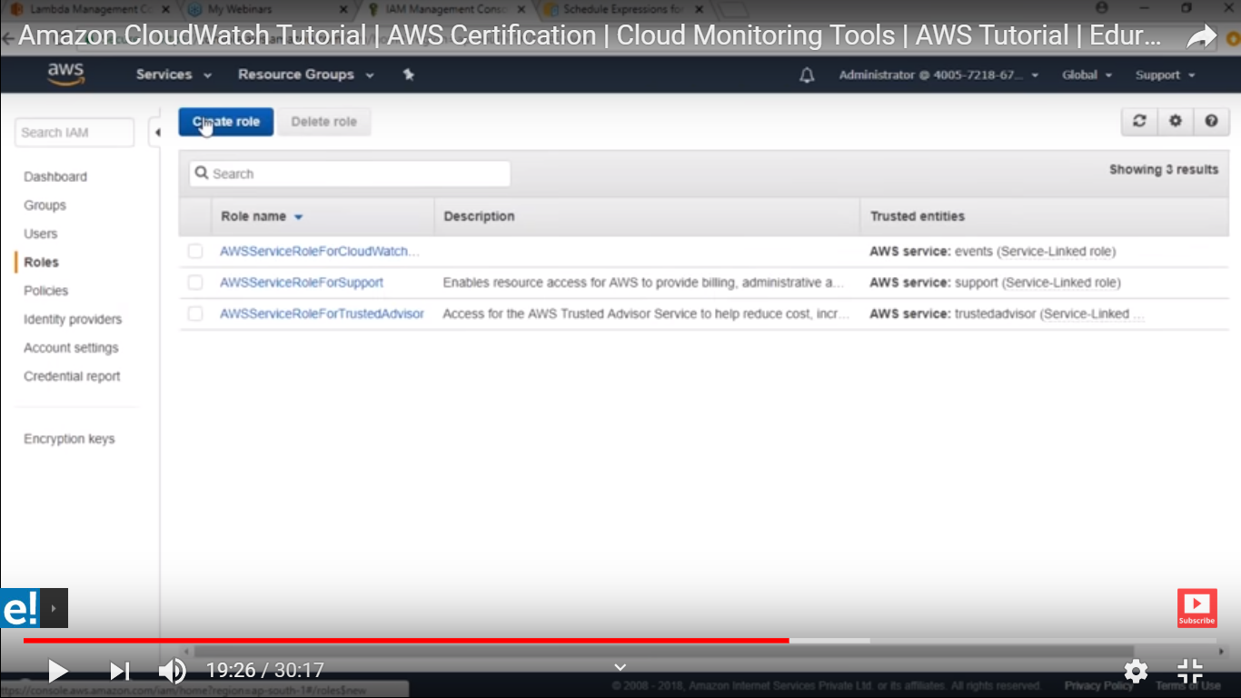

**Chose lambda function :**

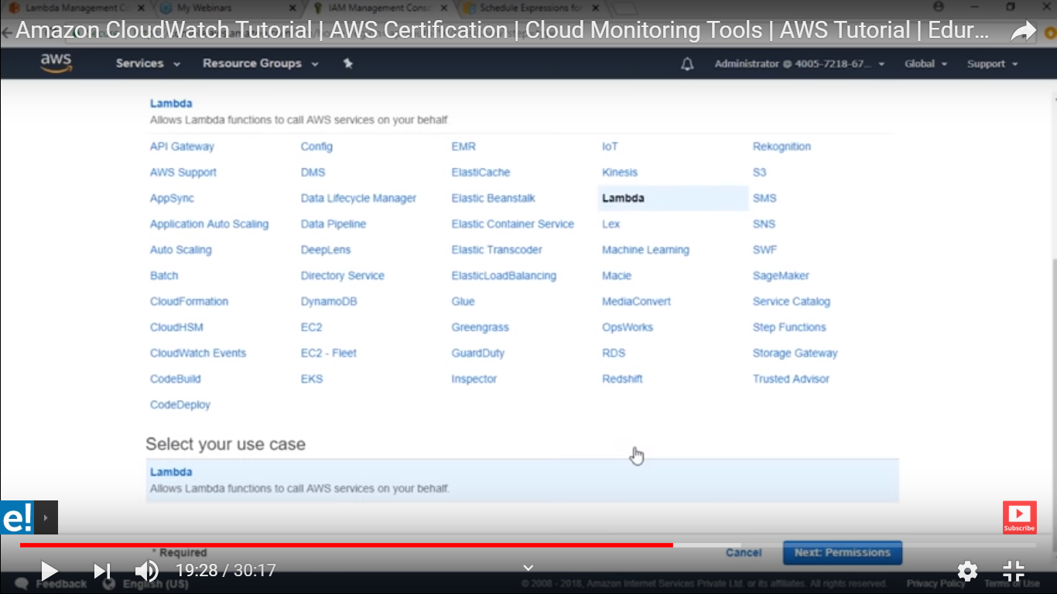

**Search polcy which you have created :**

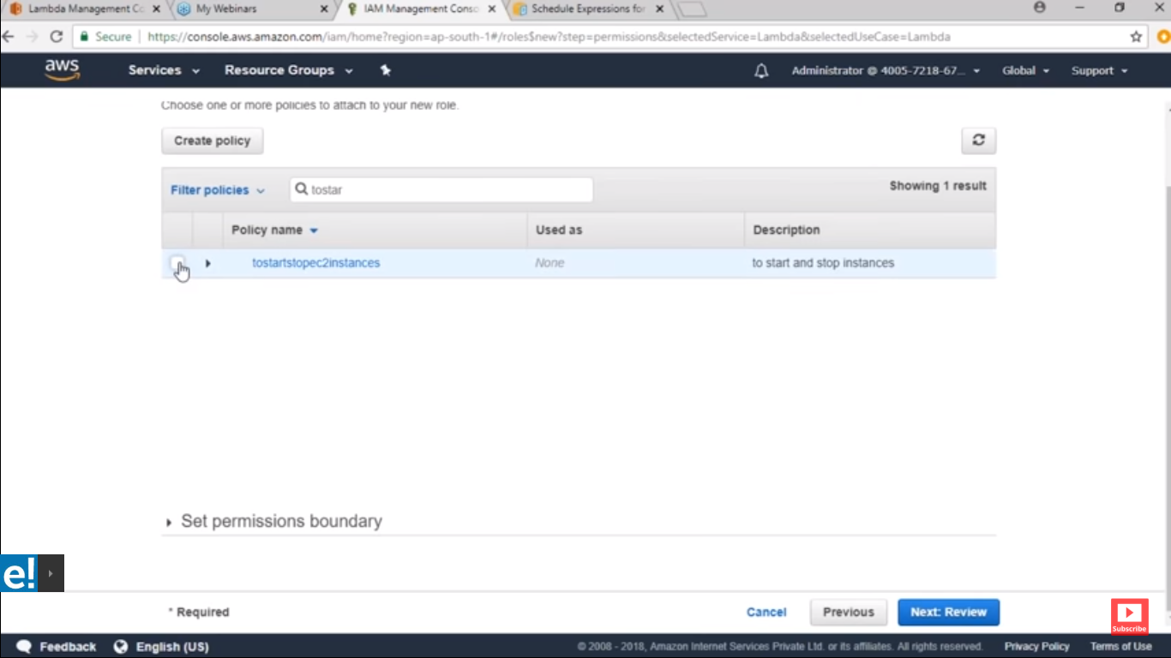

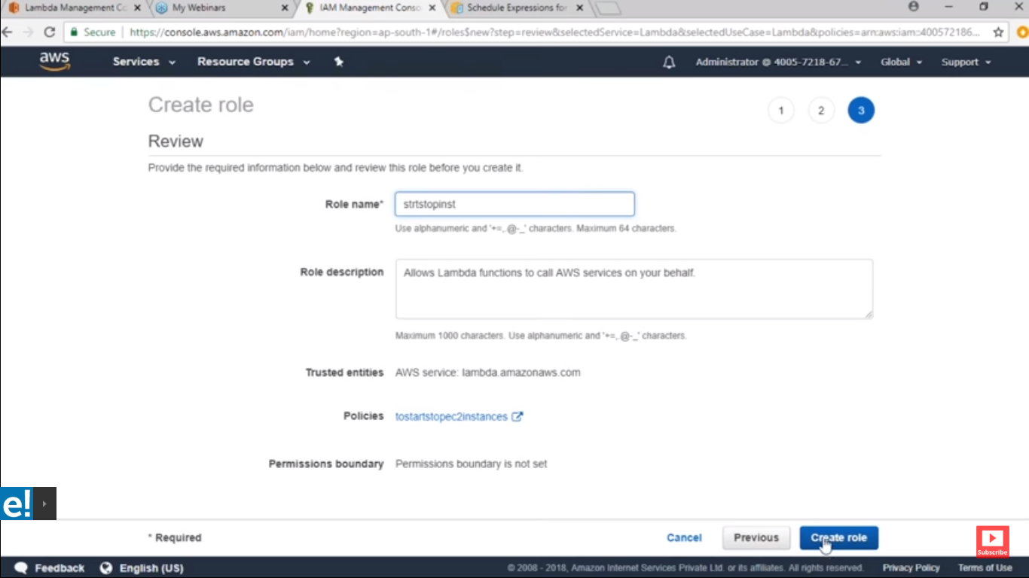

**Now create Lambda :**

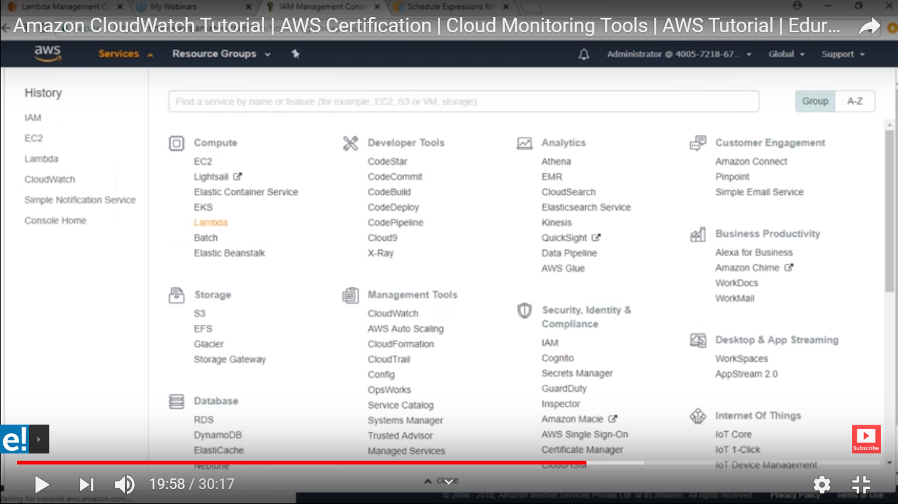

**The create function :**

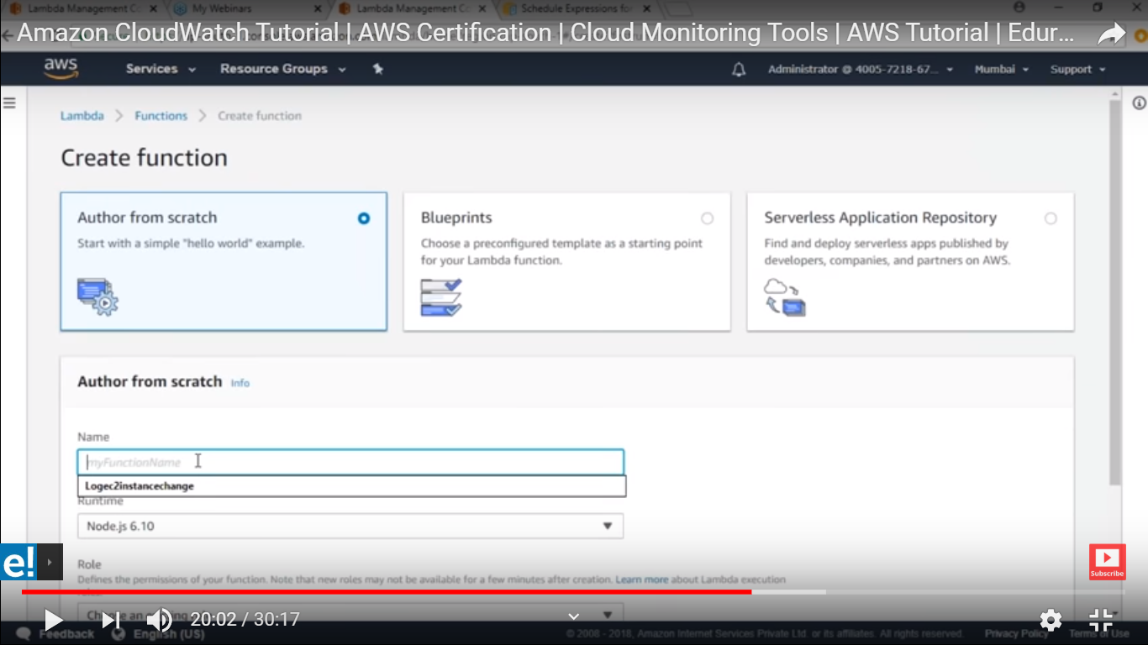

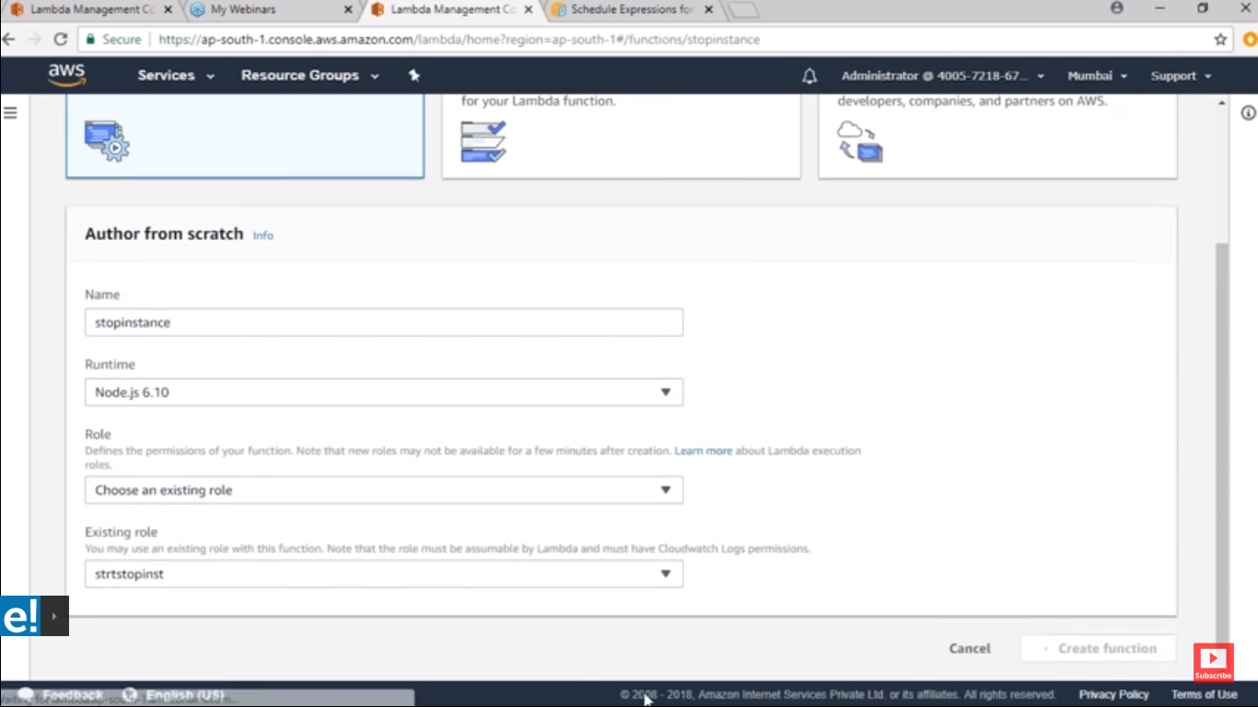

**Copy the code to stop Ec2 instance from note pad**

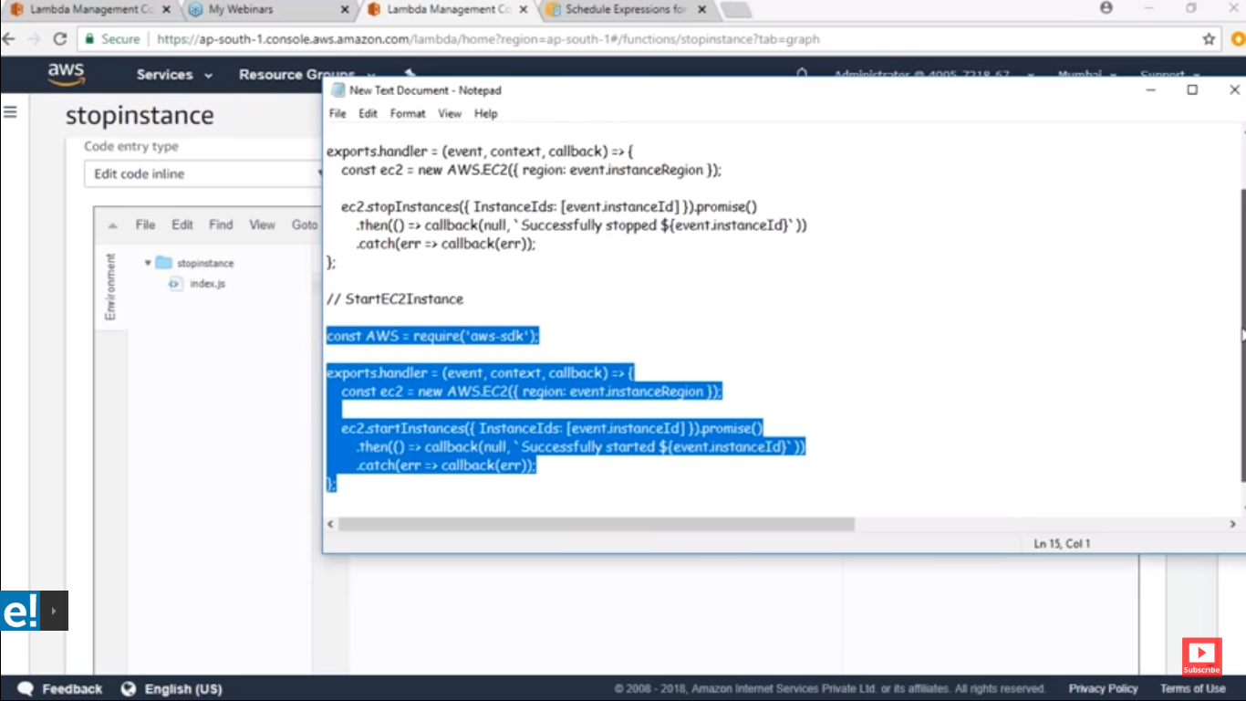

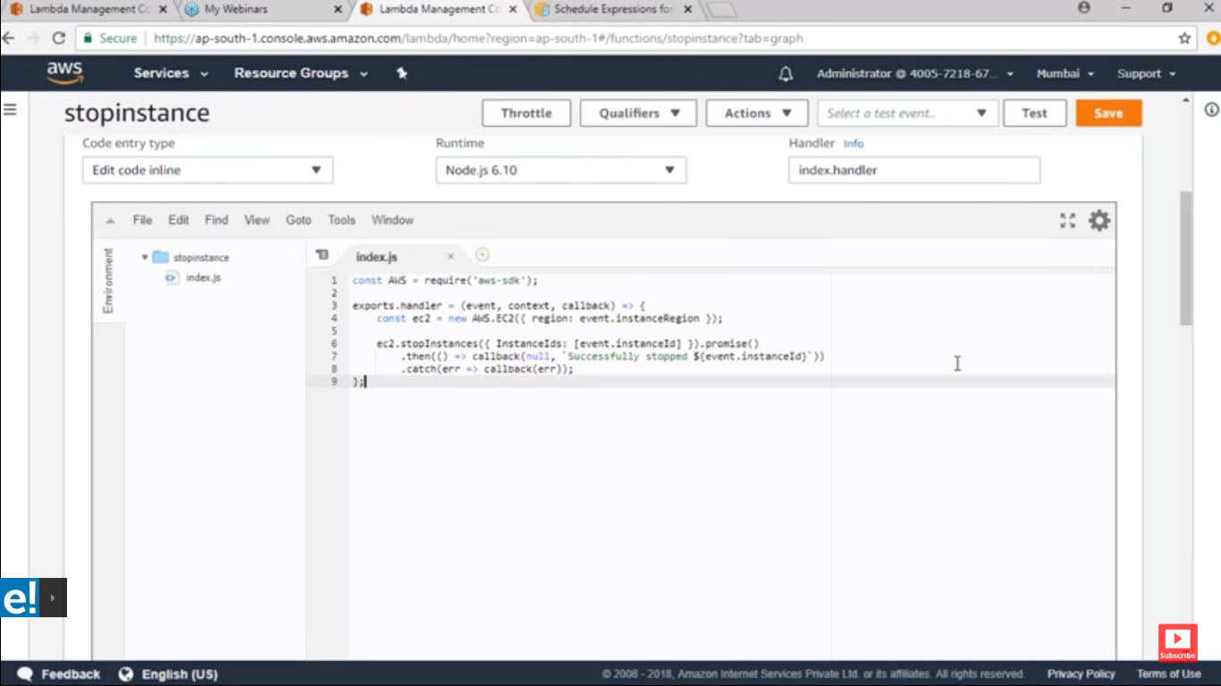

**In code you can see its asking instance resion and instance id lets configer this**

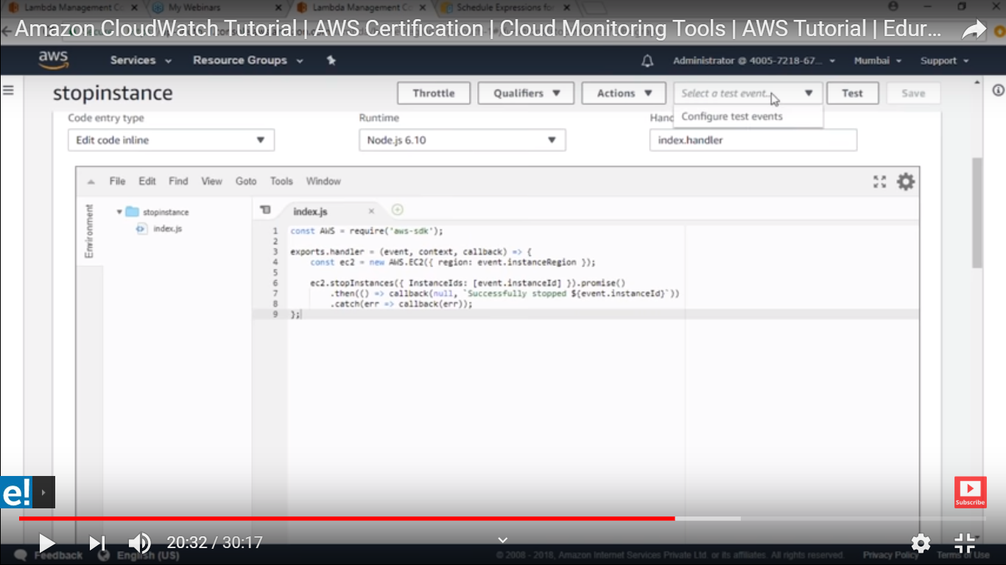

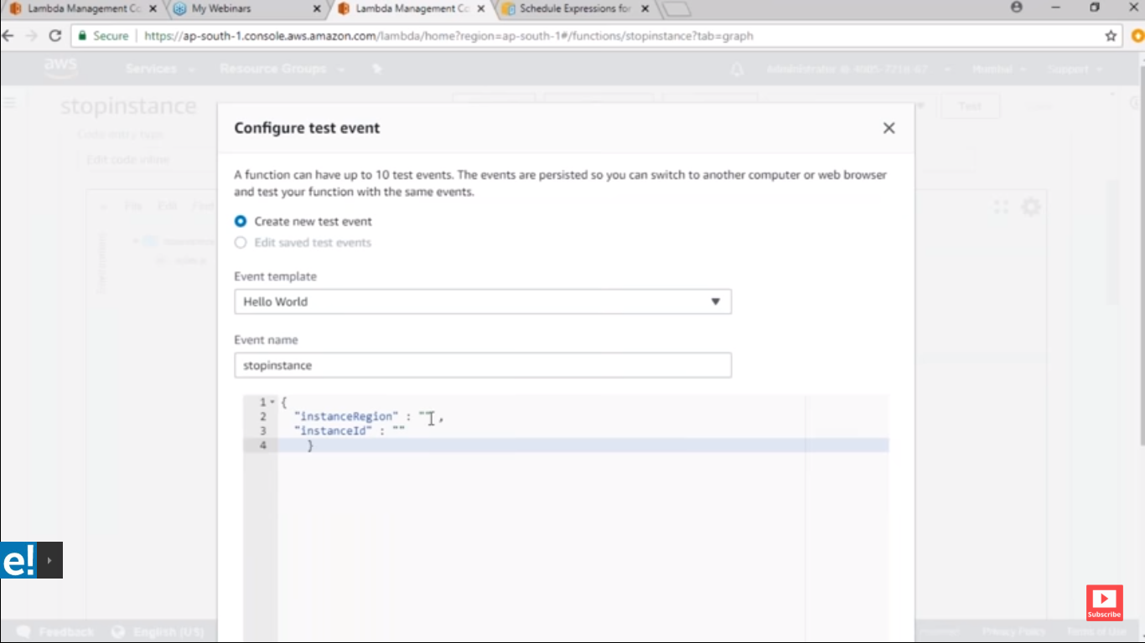

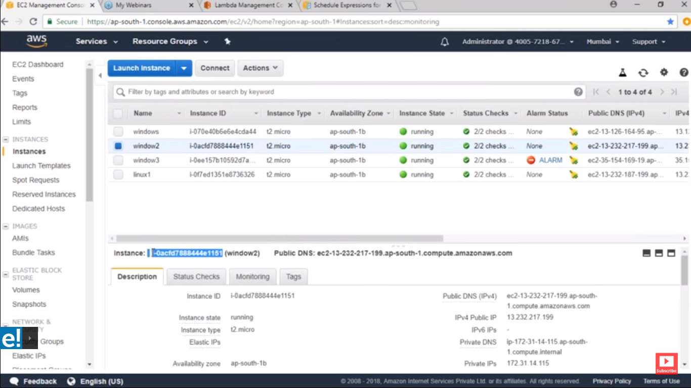

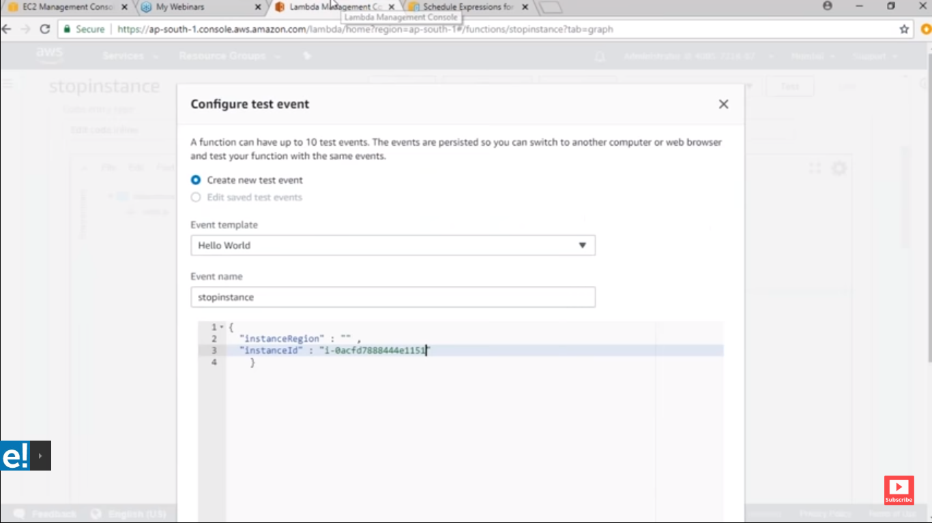

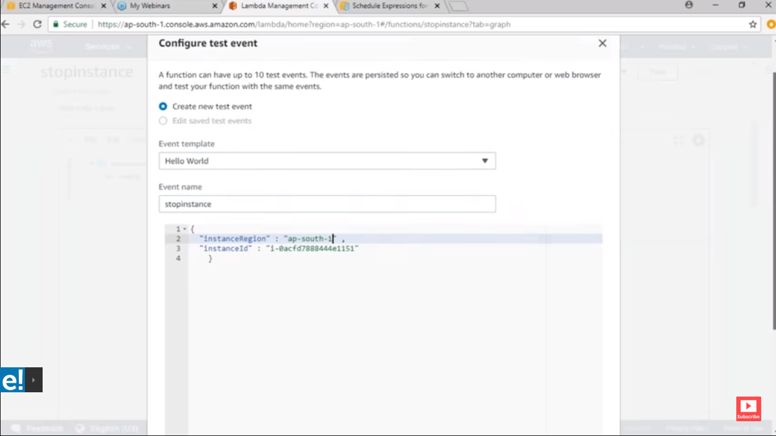

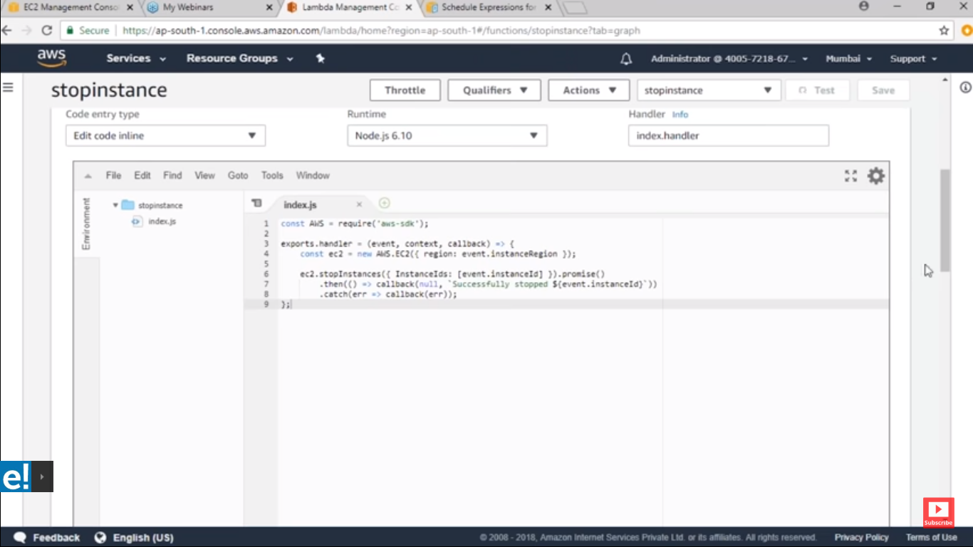

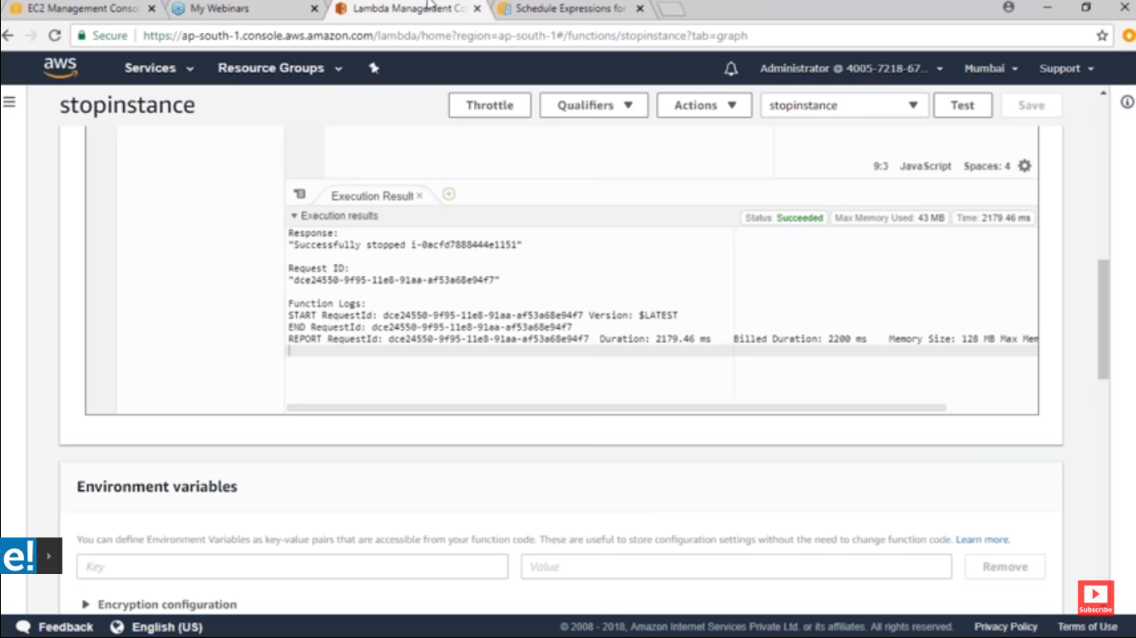

**After executing this you EC2 will stop**

**Create next lambda function to start EC2 :**

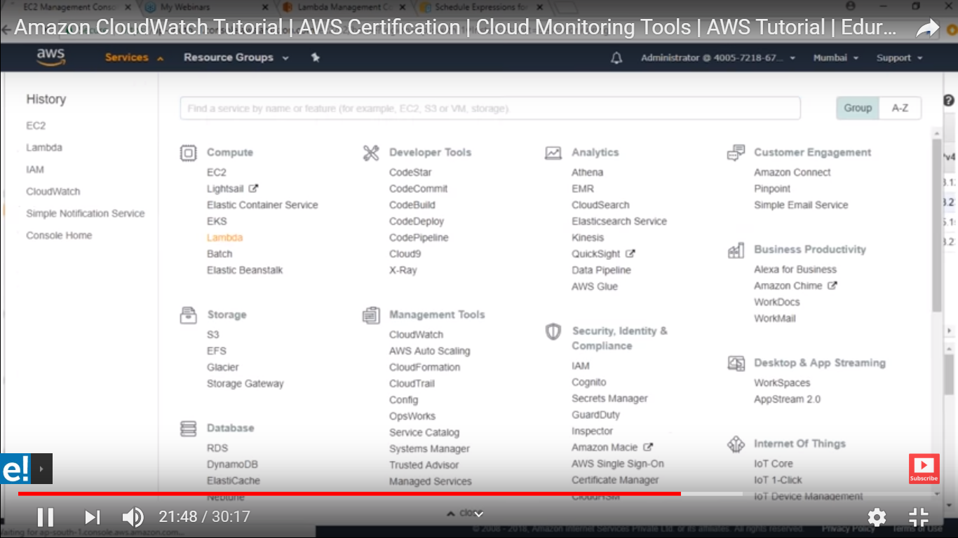

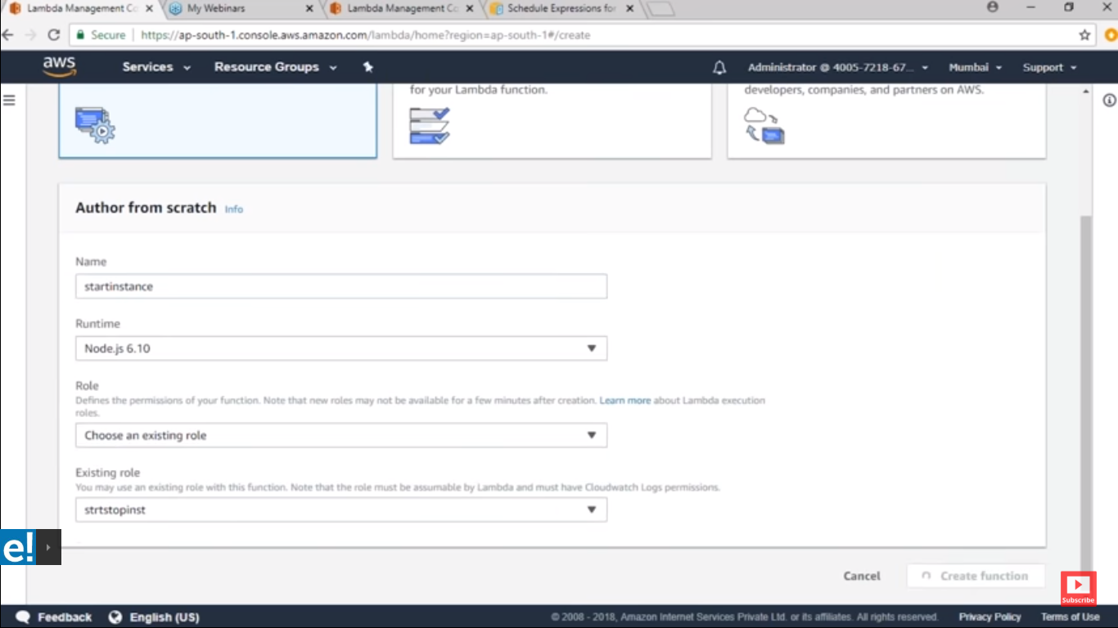

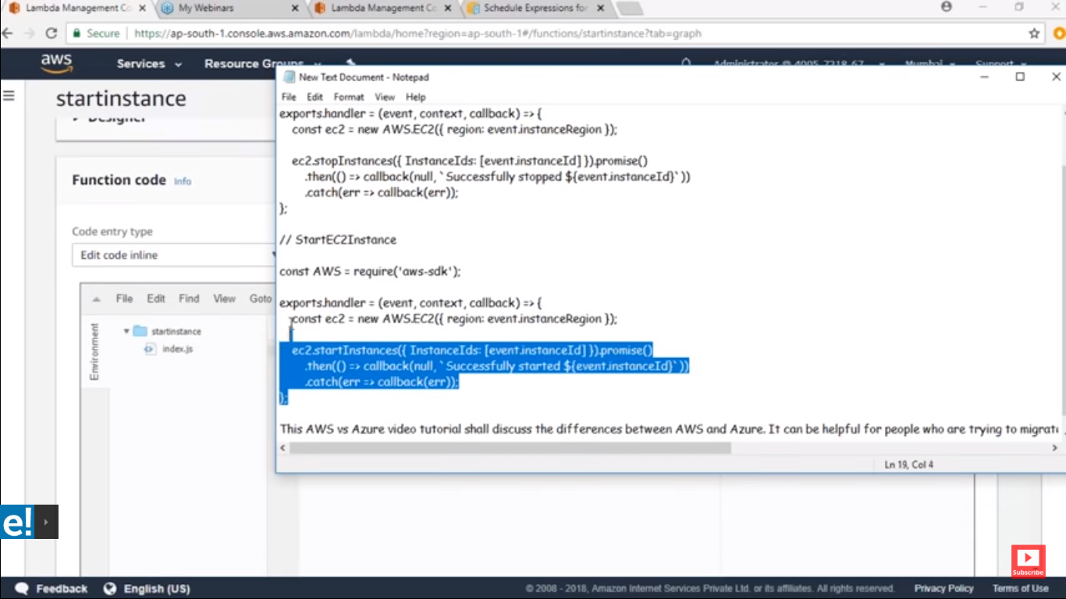

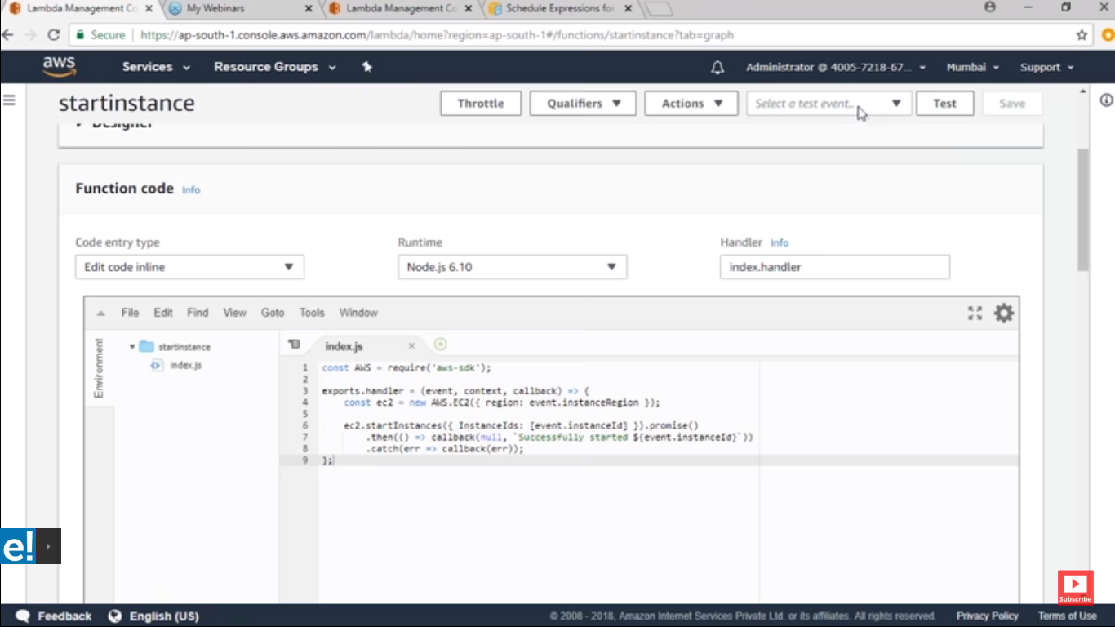

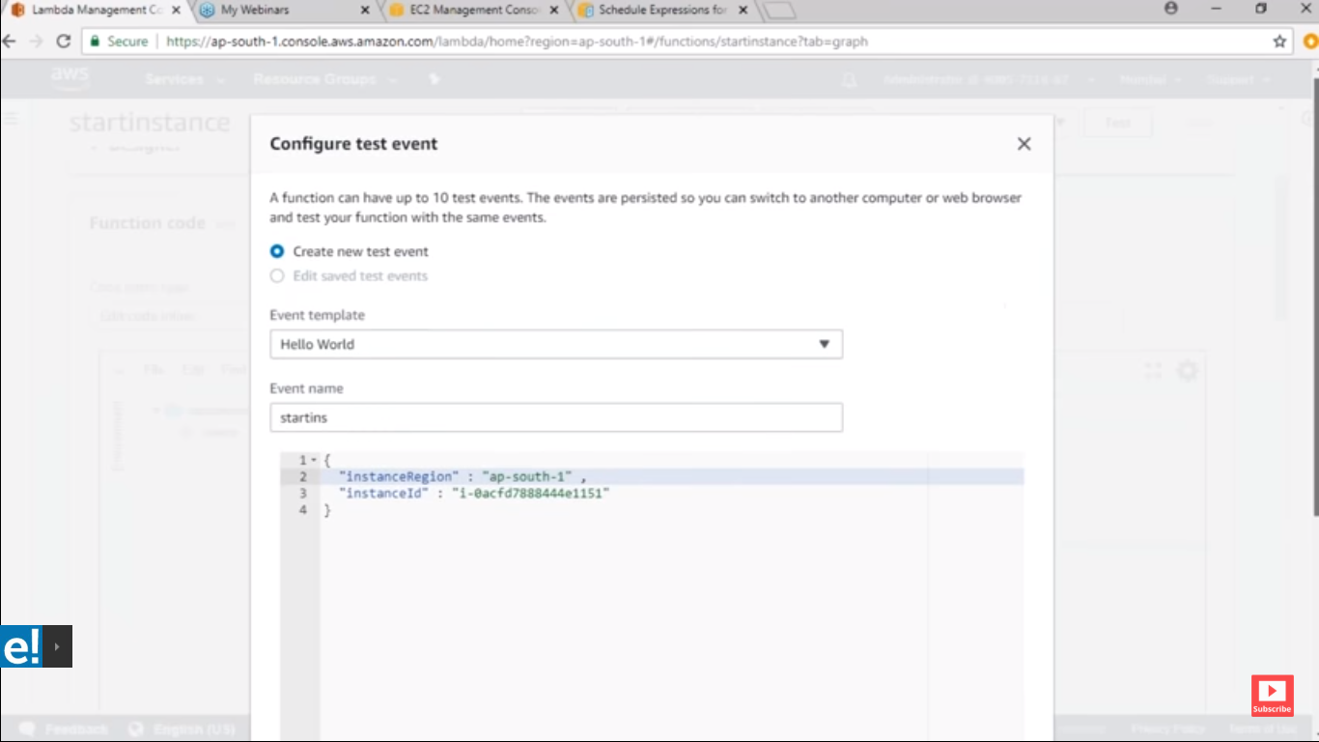

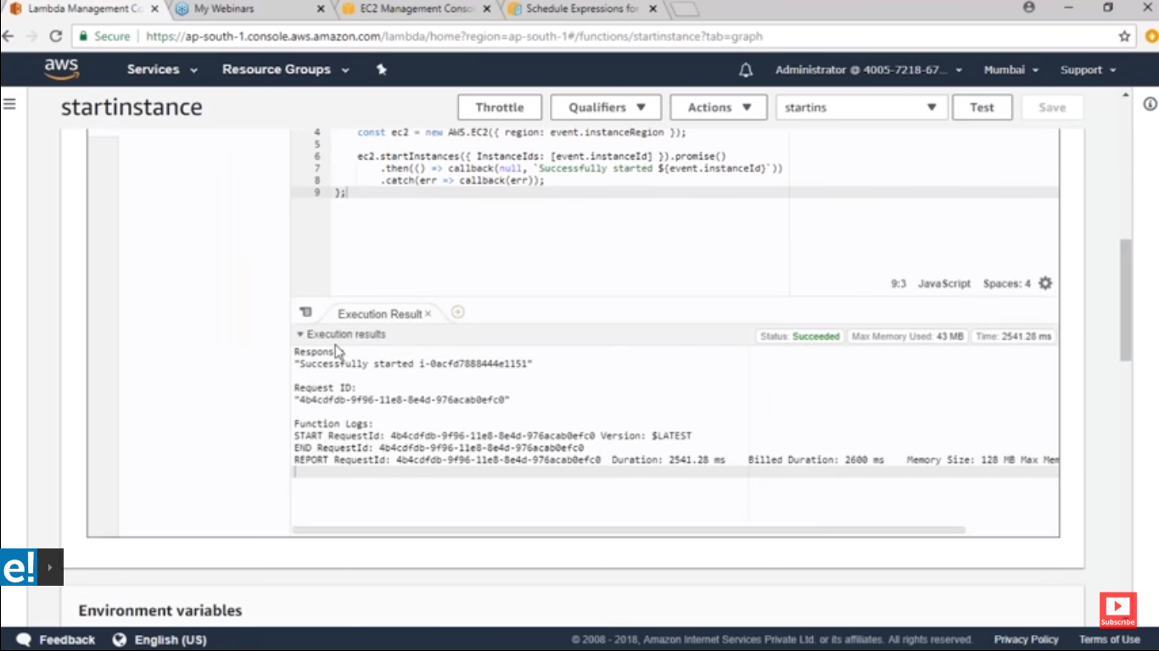

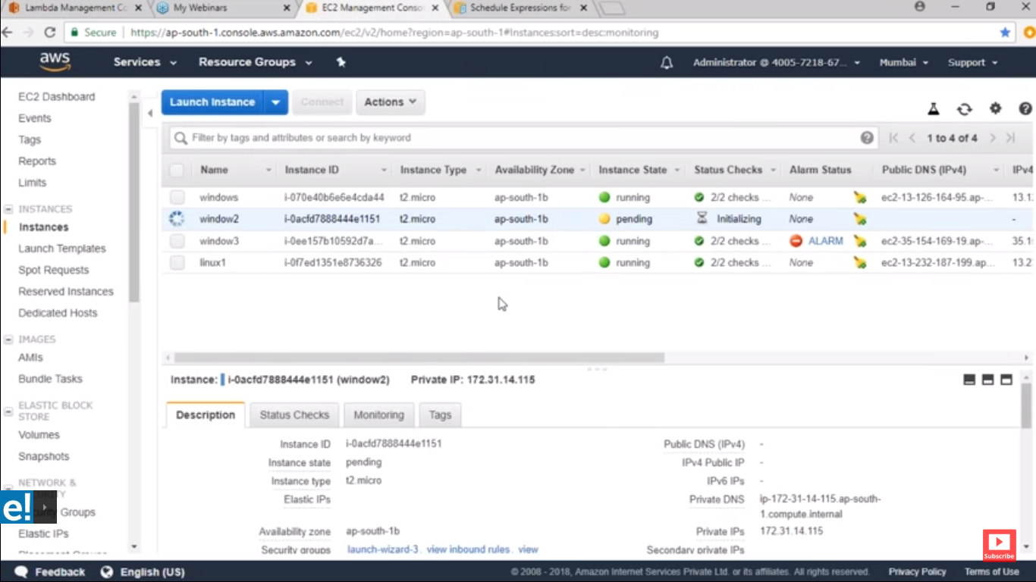

**Now I will automate this process by using cloud watch**

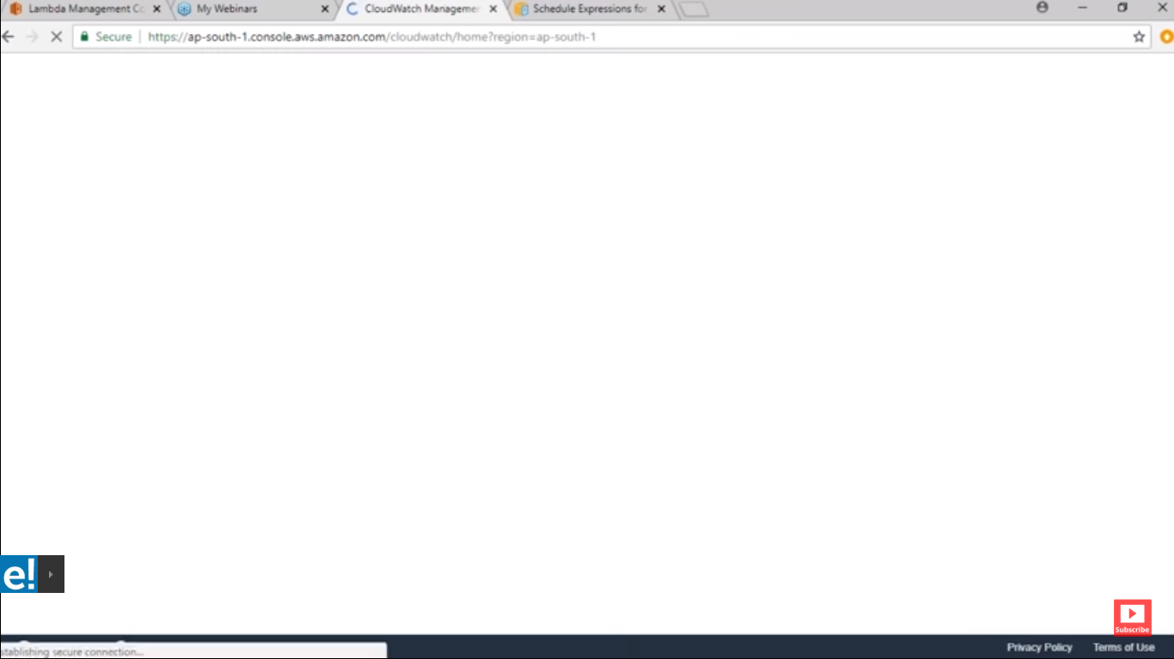

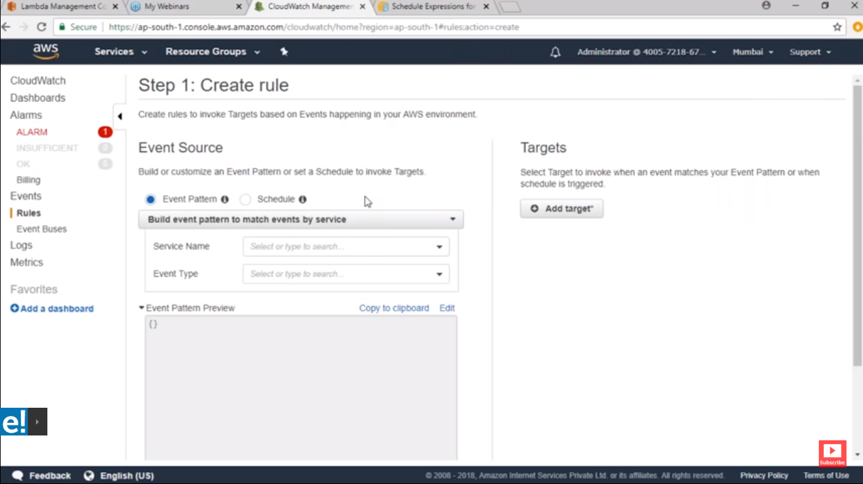

**Create schedule start instance every day 6 Am and stop it 6 Pm**

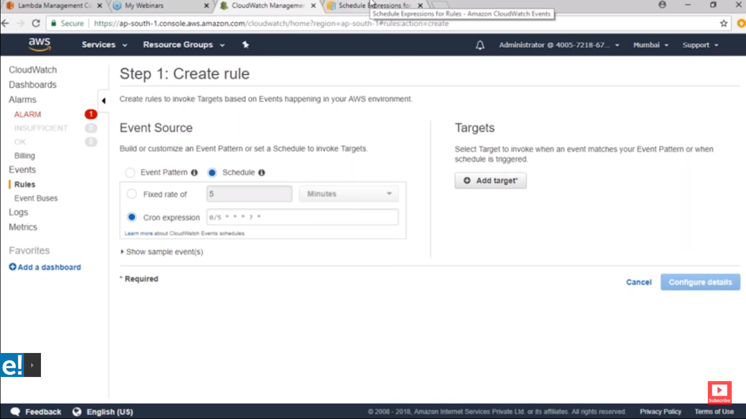

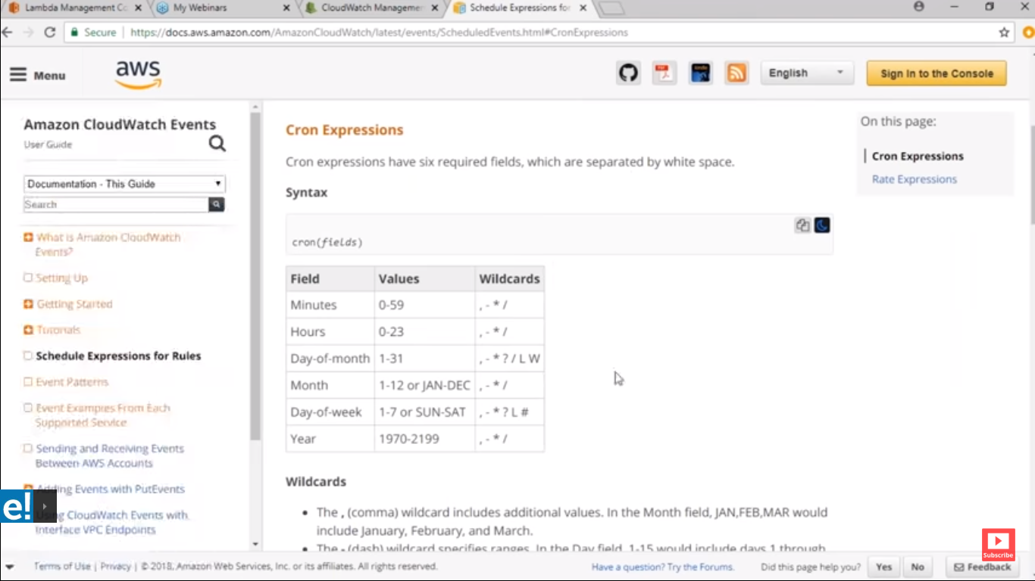

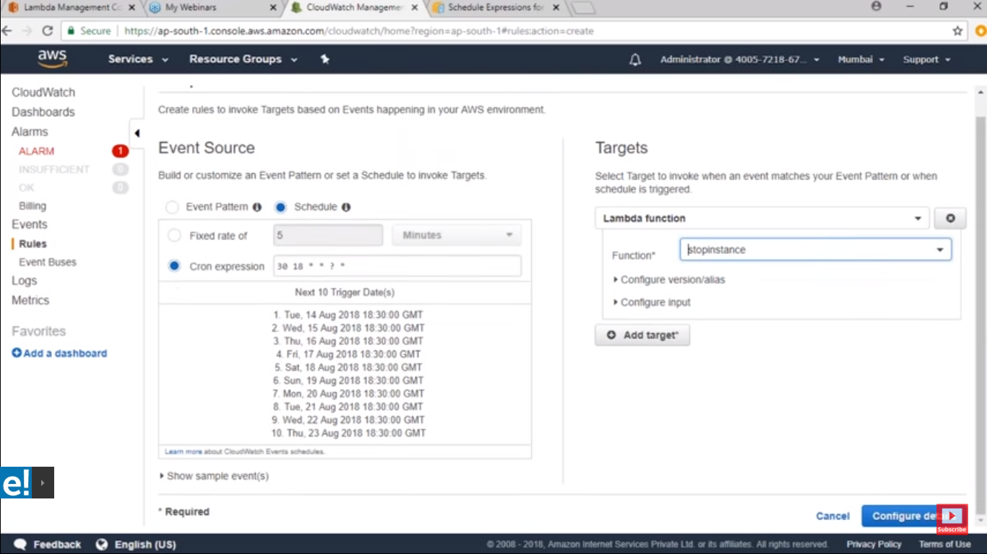

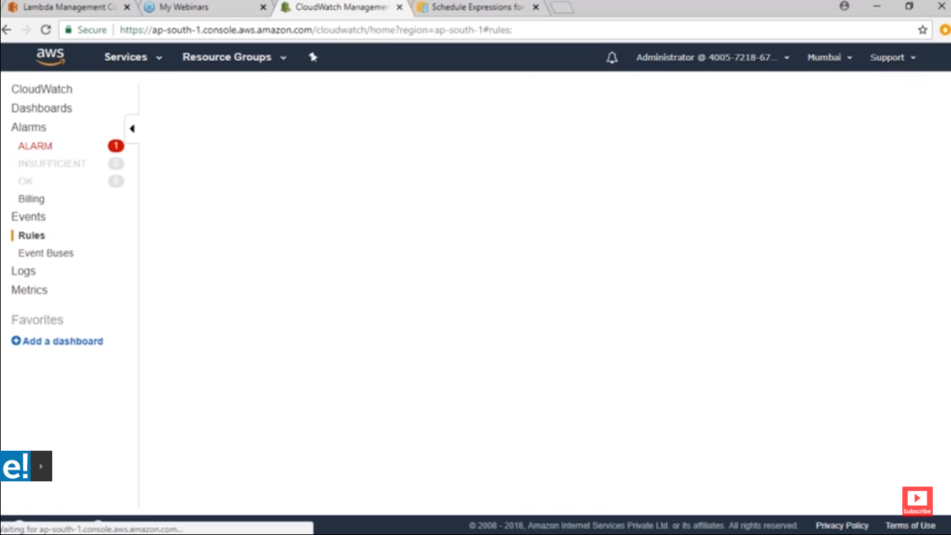

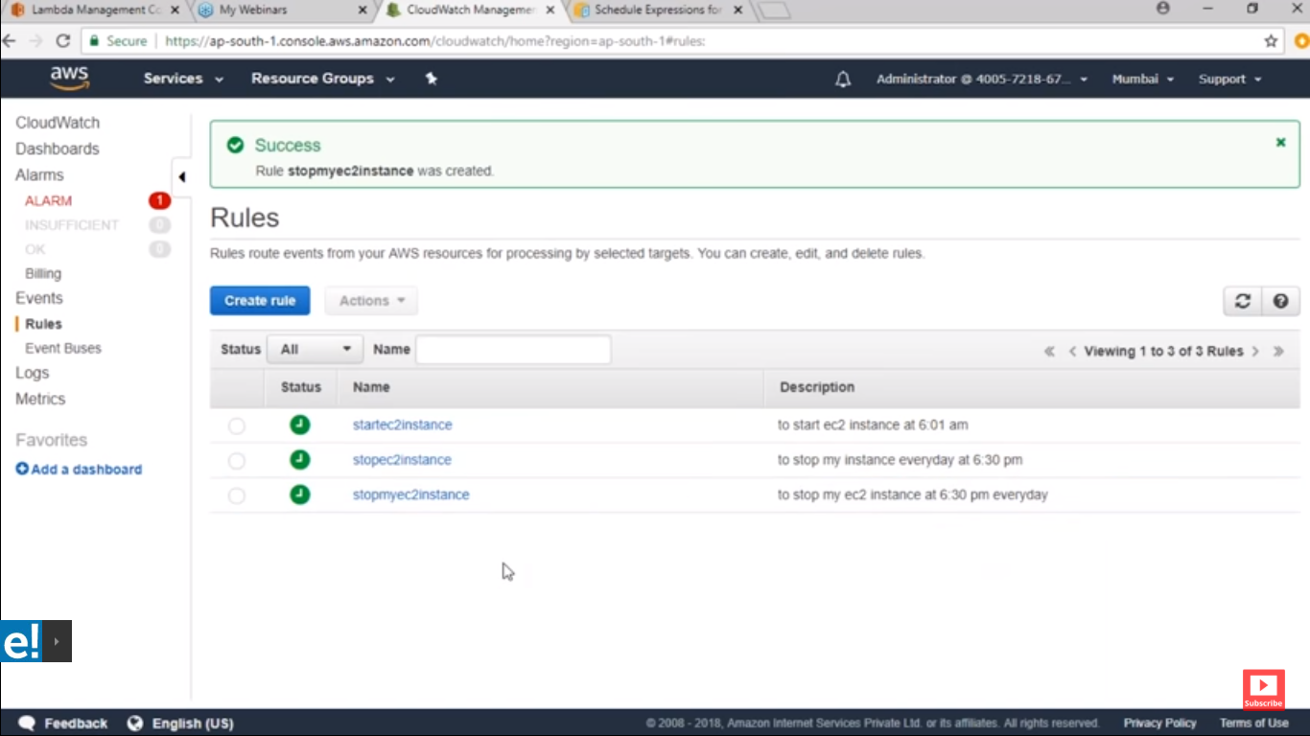

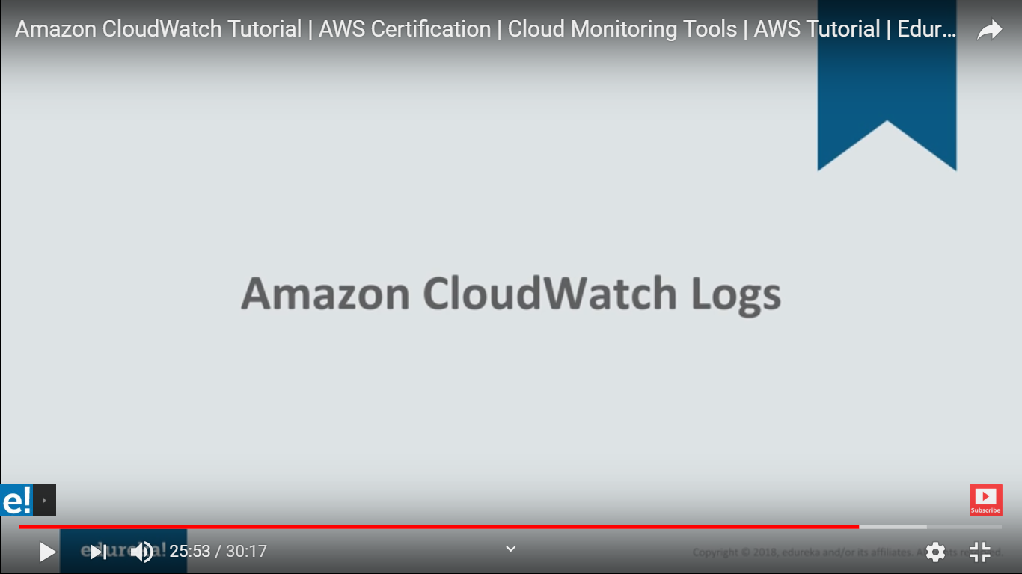

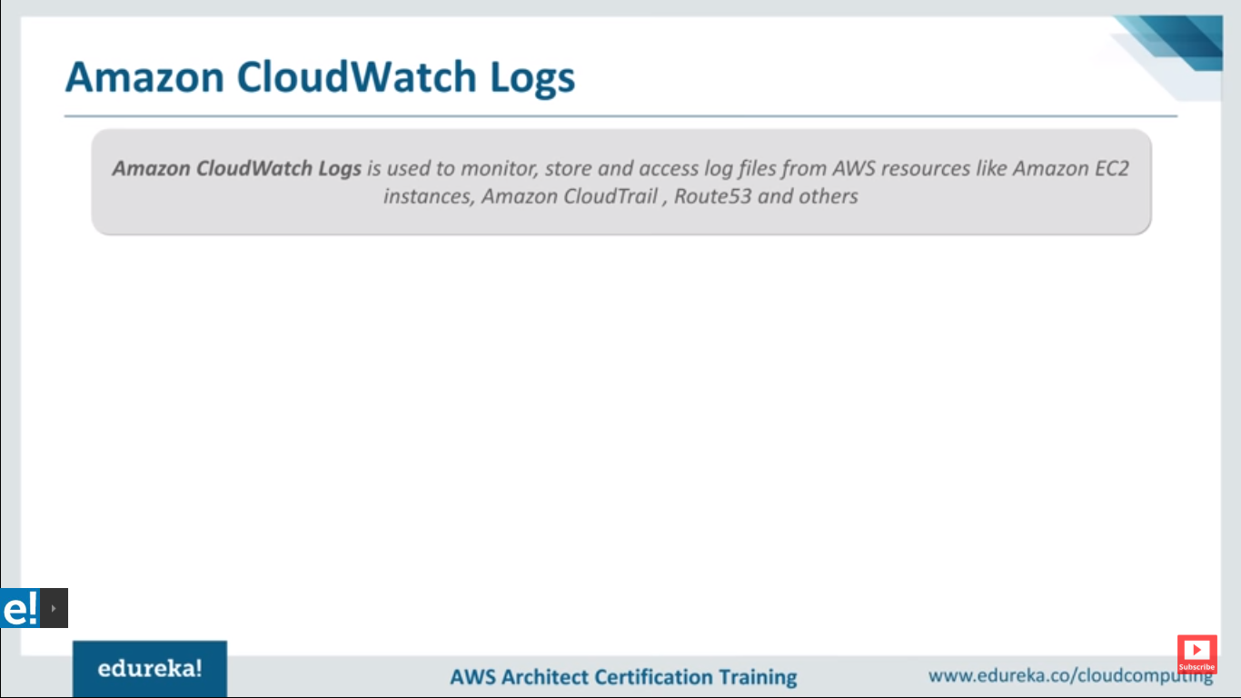

**You see logs here also this for window**

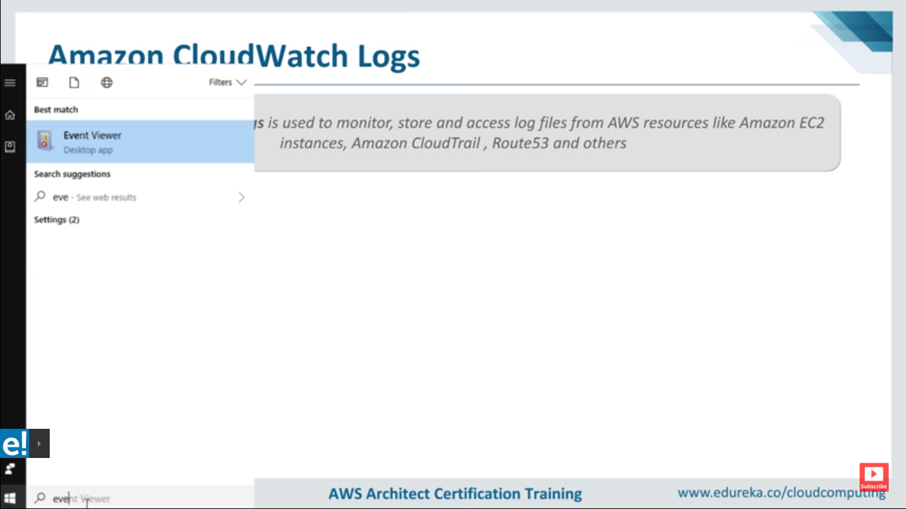

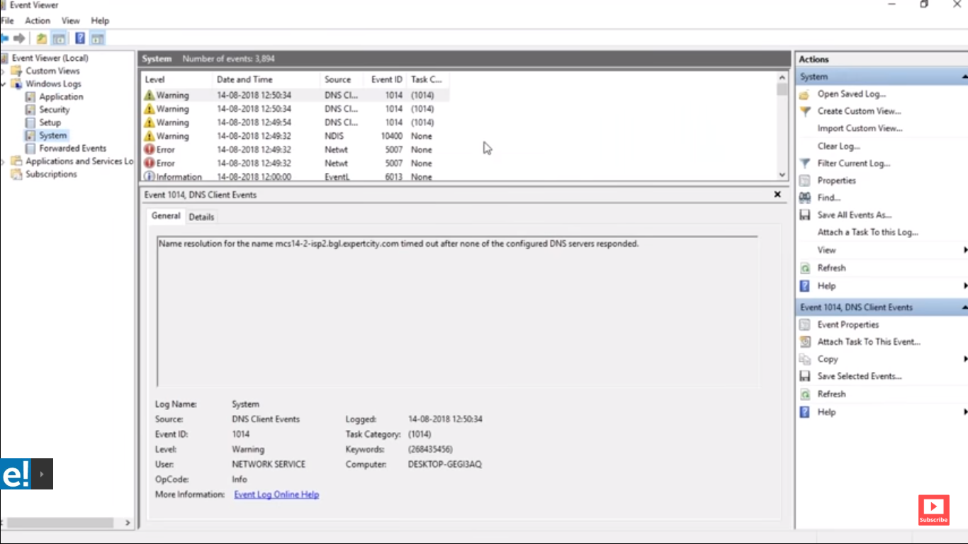

**Simlaraly we have AWS logs**

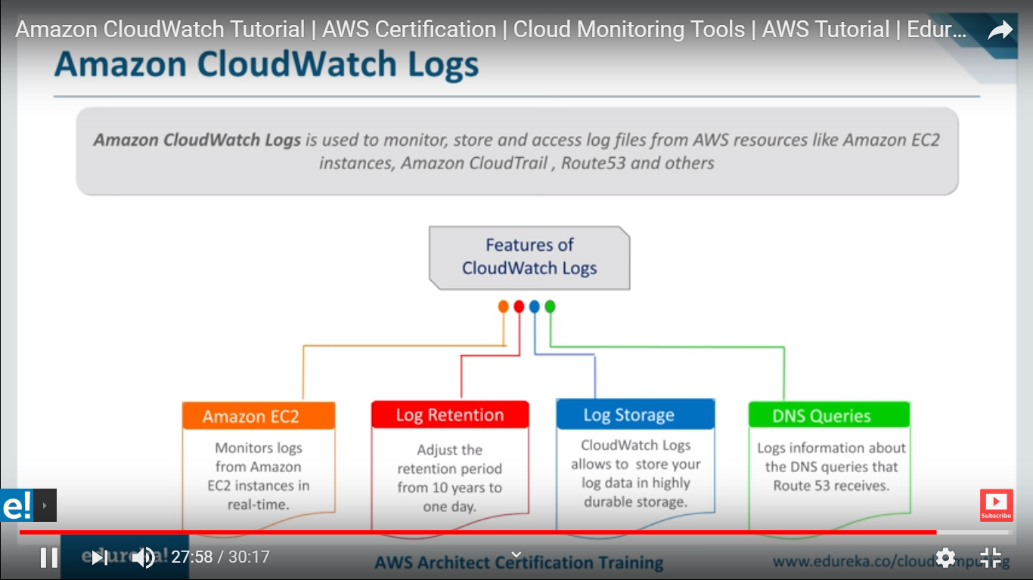

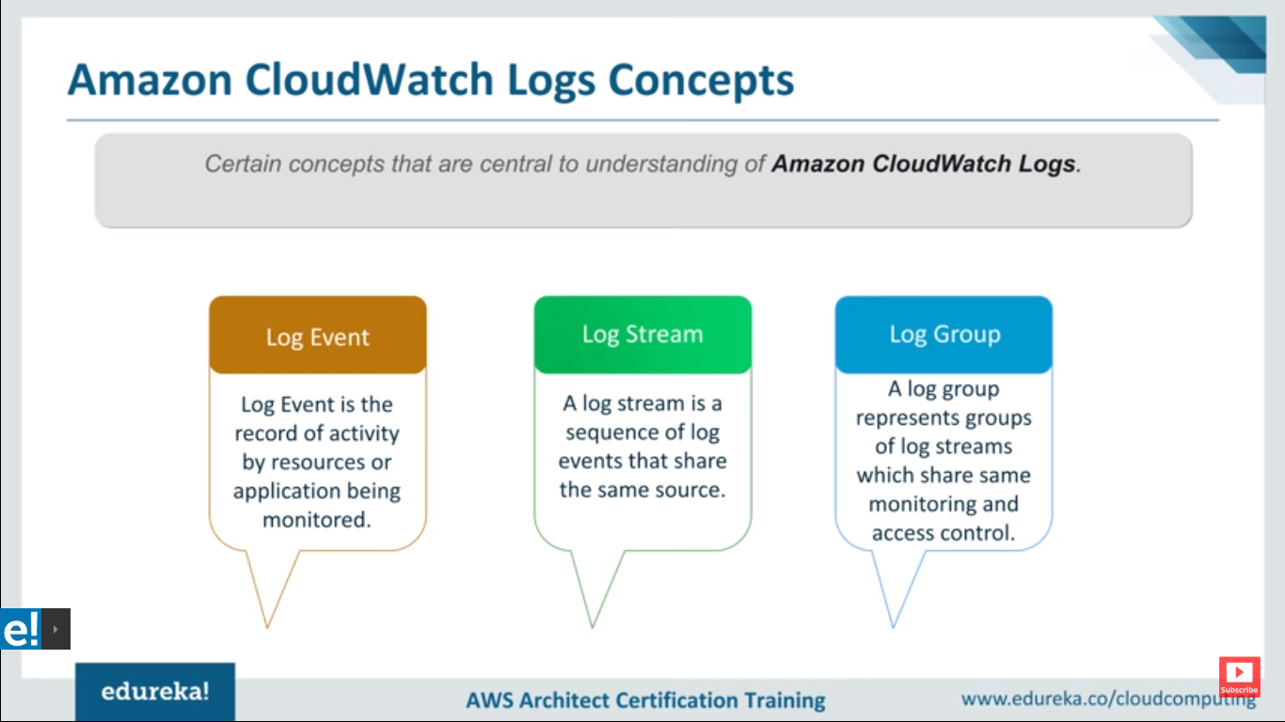

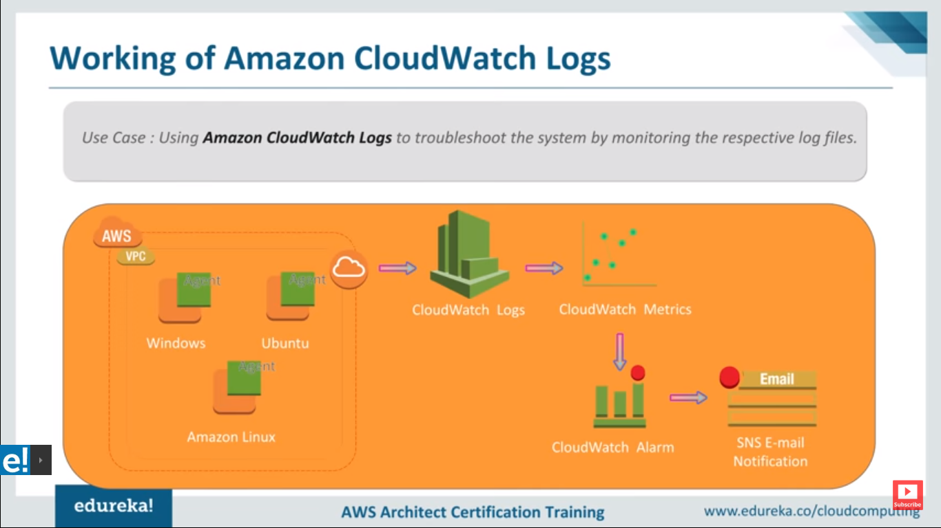

**Use cases for Cloud watches**

## **How it works**

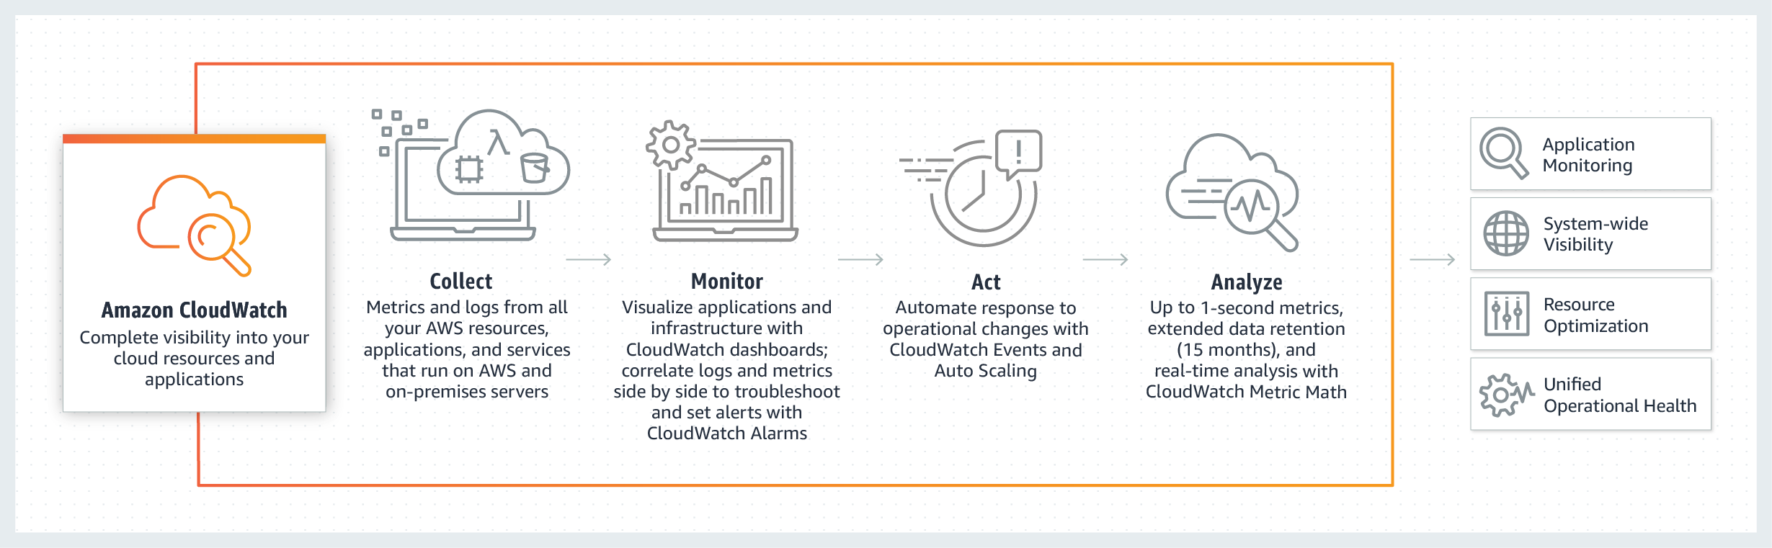

## **Use cases**

### Infrastructure monitoring and troubleshooting

Monitor key metrics and logs, visualize your application and infrastructure stack, create alarms, and correlate metrics and logs to understand and resolve root cause of performance issues.

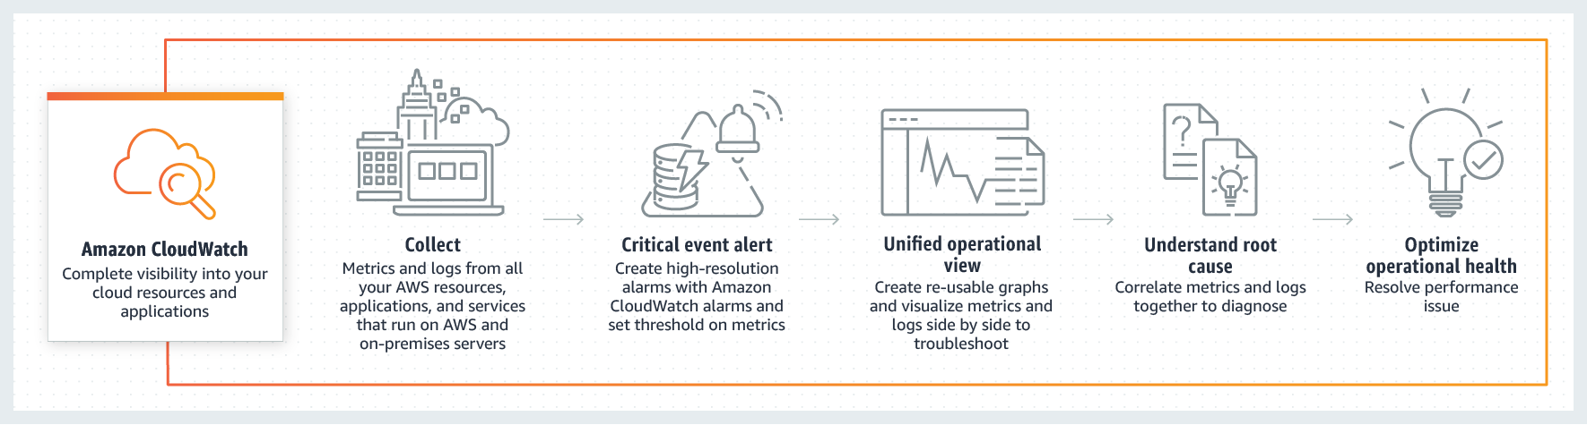

### Resource optimization

Enable CloudWatch Alarms to automate capacity and resource planning through Auto Scaling.

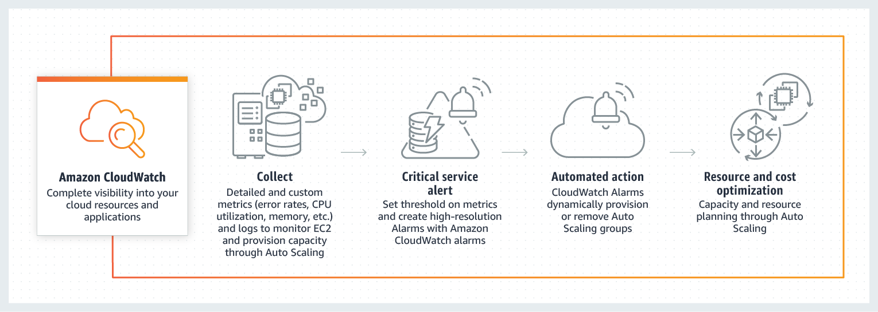

### Application monitoring

Trigger automated CloudWatch Alarms and Lambda workflows to improve customer experience.

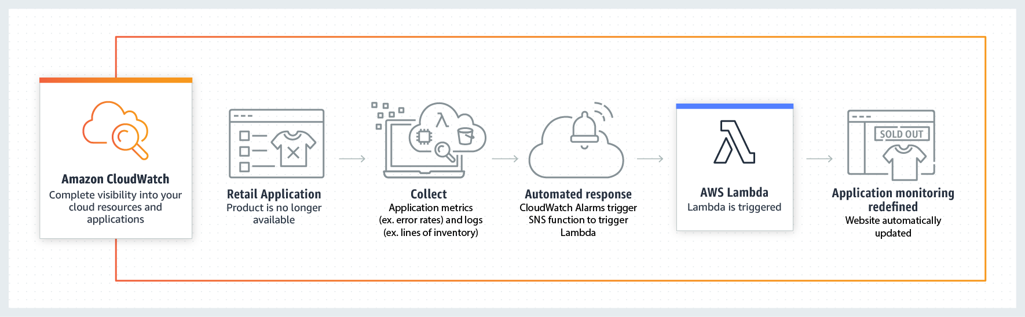

### Log analytics

Explore, analyze, and visualize your logs instantly to address operational issues and improve applications performance.

